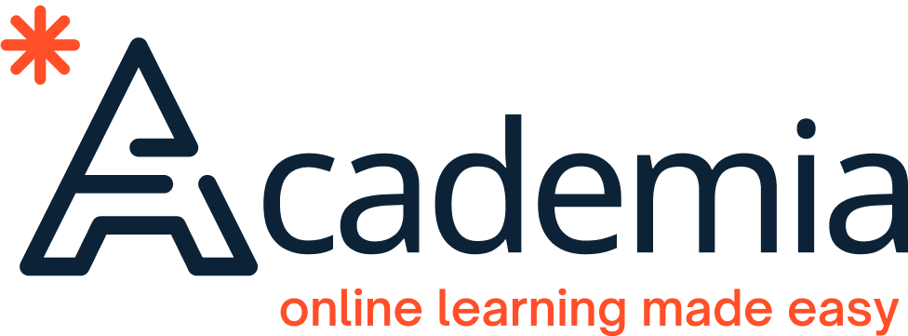

# ACADEMIA IMPROVED LEARNING MANAGEMENT SYSTEM

Graduation Project

*Presented by:*

|  |  |
| --- | --- |
| *Marwan Tamer Galal* | *20200508* |
| *Abdelrahman Mohamed Ahmed* | *20200318* |
| *Ahmed Mohammed Fayek* | *20200043* |
| *David Nael Nady* | *20200172* |
| *Mohamed Mahmoud Mohamed* | *20200474* |

*Under the supervision of*

*Assoc. Prof. Iman Helal*

*TA. Eng. Mira Rahem*



# Abstract

In response to the growing need for better LMS platforms, our project’s main mission is to create a user-friendly and highly customizable e-learning platform that benefits students, educators, and administrators alike. From students-side, the proposed e-learning system can serve as a one-stop repository for all their study materials and tools. This system is designed to make their learning journey as smooth as possible. From educators-side, the system can provide a seamless teaching environment, fostering communication and personalization. Finally, administrators are able to gain analytical insights for informed decision-making.

The proposed e-learning system covers core areas presented in other e-learning systems. Also, it ensures accessibility and usability for students, efficient course management for teachers, and streamlined data retrieval for administrators. Other complex features like AI assistance or video conferencing are out-of-our scope due to time and resource constraints.

We are adopting an agile approach, allowing us to adapt as we go. This report includes chapters on market analysis, project details, system design, testing, results, and future possibilities. You can also find additional reports in the appendices for a deeper dive into our project journey.

**Keywords**: Learning Management System, LMS, Course Management, XAPI.

# Table Of Contents

Table of Contents

ACADEMIA IMPROVED LEARNING MANAGEMENT SYSTEM 1

Abstract 2

Table Of Contents 3

List of Tables 6

List of Figures 7

List of Acronyms 8

Chapter 1: Introduction of the Project and its Vision. 10

1.1 Background and Motivation 10

1.2 Problem Statement 10

1.3 Objectives 10

1.4 Project Scope and Limitations 11

1.5 Project Methodology 11

1.6 Project Report Outline 11

1.7 Project Timeline 12

1.8 Workload Distribution 13

Chapter 2: Market and Literature Survey 14

2.1 Competitors 14

▪ Blackboard 14

▪ Thinqi 14

▪ Google Classroom 14

▪ Ain Shams 14

2.2 Competitor Analysis 15

2.3 SWOT Analysis 17

2.4 Features 18

■ The key features 18

■ Leading principals 18

Chapter 3: Analysis 19

3.1 Data Gathering 19

3.2 Survey Structure 19

3.3 Analysis Steps 20

3.4 Survey Results 22

3.5 Project Preliminary Requirements 23

■ Must Have Features: 24

■ Should Have Features: 24

■ Nice to Have Features: 25

■ Functional requirements: 25

■ Non-functional: 26

3.6 User Research 26

3.6.1 Background 26

3.6.2 Objectives 26

3.6.3 Research Methods 27

3.6.4 Participant Recruitment 27

3.6.5 Data Collection 27

3.6.6 Student Users Profiles 27

3.6.7 Teaching Staff Users Profiles 27

3.6.8 Student Management Users Profiles 27

3.6.9 Dashboard Design 27

3.6.10 Content Formats and Customization 28

3.6.11 Communication and Collaboration 28

3.6.12 Accessibility and User-Friendliness 28

3.7 User Persona 28

3.8 *Use Casses* 33

3.9 Use Case Diagram 40

3.10 Use Case Descriptions 42

Chapter 4: Design 45

4.1 Architecture 45

4.2 Class Diagram 46

4.3 BPMN Diagrams 46

4.4 Sequence Diagrams 48

4.5 User Interface Screens 49

Appendix 50

A. Competitor Analysis 50

B. Student Survey 50

C. Teacher Survey 50

D. Use Case Descriptions 50

E. Use Case Diagrams/BPMN/Sequence diagrams/ERD 50

F. Responses and data analysis 50

G. Students Survey Statistics Results: 50

a. Blackboard Learn 54

b. Google Classroom Users 57

F. User Research Plan 60

G. User Research Report 60

H. Initial Requirements 63

I. Use Cases Brief 69

J. Data Standard 72

1. Verbs id-enum: 72

2. Objects Enum: 75

3. Privileges Enum: 75

4. Statement Structure: 76

# List of Tables

Table 1 Project Timeline 11

Table 2 Competitor Analysis 14

Table 3 Use Case Description 1 41

Table 4 Use Case Description 2 42

Table 5 Use Case Description 3 43

Table 6 Verbs Enums 71

Table 7 Objects Enums 74

Table 8 Privileges Enums 74

Table 9 Timestamp Standard 74

# List of Figures

Figure 1Survey Analysis Steps 21

Figure 2 User use case diagram 40

Figure 3 Student use case Diagram. 40

Figure 4 Administrator use case Diagram. 41

Figure 5 Teacher use case Diagram. 41

Figure 6 high-level architecture. 45

Figure 7 Student BPMN Diagram 46

Figure 8 Teacher BPMN Diagram 47

Figure 9 Student Sequence Diagrams 48

Figure 10 Home | Filled State 49

Figure 11 Add Course 49

Figure 12 Login | Empty State 49

Figure 13 Single Course 49

Figure 14 Quizzes List 49

Figure 15 Calendar. 49

Figure 16 Survey Language Chart 51

Figure 17 Survey University Year Chart 51

Figure 18 Survey University Chart 52

Figure 19 Survey Faculty Chart 52

Figure 20 Survey LMS Previous Usage Chart 53

Figure 21 Survey LMS Cumulative Usage Chart 53

Figure 22 Survey Preferred LMS Chart 54

# List of Acronyms

|  |  |
| --- | --- |
| **Acronym** | **Stands for** |
| AI | Artificial Intelligence |
| API | Application Programming Interface |
| Apps | Applications |
| Ar | Arabic |
| AWS | Amazon Web Services |
| BPM | Business Process Model |
| BPMN | Business Process Model and Notation |
| COVID-19 | Coronavirus disease of 2019 |
| E-Learning | Electronic Learning |
| En | English |
| ERD | Entity Relationship Diagram |
| JSON | JavaScript Object Notation |
| LMS | Learning Management System |
| MVC | Model View Controller |
| PDF | portable document format |
| SCORM | Sharable Content Object Reference Model |
| SWOT | Strengths, Weaknesses, Opportunities, Threats |
| UI | User Interface |
| UX | User Experience |
| WCAG | Web Consortium Accessibility Guidelines |
| XAPI | Experience API |
|  |  |

# 

# Chapter 1: Introduction of the Project and its Vision.



## Background and Motivation

Hybrid learning has become increasingly important since the COVID-19 pandemic began in 2020. To meet this new demand in the market, numerous platforms and applications have emerged to cater to educational institutions, individual trainers, and software companies that create platforms for specific fields of education. Each platform has its unique advantages and disadvantages, but most suffer from issues such as low usability, difficult maintenance, and a focus on specific types of education. Our team recognizes the need for a better platform and has decided to develop one to meet the needs of learners and educators.

## Problem Statement

The present problem is the lack of LMS (Learning Management System) and proper LMS usage in the Egyptian market which hinders the progress and user experience of many learners which opens the way for the creation of new LMSs catered to the Egyptian/Arabic population.

## Objectives

Our team's objective and vision are to create an E-learning (Electronic Learning) platform that provides a perfect learning environment for students, teaching staff, and management. We aim to create a platform that is easy to use, customizable and provides all the necessary tools for learners and educators to succeed.

* For students, we envision a platform that acts as their personal repository containing all their studying material and all the tools they need to succeed in their specific field of study.
* For educators, we envision a platform that provides a seamless environment for communication, monitoring, connecting with students, and delivering personalized education. Our platform will allow them to create their personalized classroom with every tool they need to provide the best possible education for their students.
* For management, we aim to provide an analytical platform that enables them to review and evaluate their teaching staff and courses, providing a data-driven approach to decision-making.

## Project Scope and Limitations

The Current agreed scope is an LMS that covers students' accessibility to content and their user experience, covers teachers' needs for easy-to-modify and manage live courses, and lastly covers the administration's needs for an easy-to-use interface to pull relevant data and analyse it.

All other subjects that do not directly fall under those 3 categories are outside the scope of starting the project, for example, customized learning paths for each student, AI (Artificial Intelligence) assistance, and video conferencing.

Some limitations of this project are its system requirements as LMSs need optimized services to allow thousands of students to connect at the same time, thus some hardware limitations may be specified depending on the chosen architecture.

## Project Methodology

The chosen Methodology will be agile. Though we have a clear end goal, we still require more research and testing to realize the actual structure and architecture which means that some features may be added and removed as necessary, so the Agile methodology will allow us more flexibility to review and change goals, scope and design as necessarily, its greatest benefit will be the teams' ability to cross work on different tasks to ensure continuous improvement and progress towards the end goal.

## Project Report Outline

For this report we followed the report guidelines. Chapter 2 is concerned with market analysis and literature survey. Chapter 3 is concerned with the project analysis where we conducted a survey to output the main features and their prospective functional and non-functional requirements. Chapter 4 is concerned with the design and the architecture of the system, detailing class diagrams, ERDs (Entity Relation Diagram), BPMs (business Process Model), etc. Chapter 5 is concerned with testing and evaluating the system and its features. Chapter 6 is the last chapter focusing on the results of the project and possible future works. Lastly, the Appendix which contains detailed copies of the reports used during this project development or refers to the appendix Folder which contains the actual reports.

Table 1 Project Timeline

## Project Timeline

## Workload Distribution

**Marwan:**

* Coordination of Work.
* Documentation writing and maintenance.
* System Features and Requirements.
* System Specification.
* Database System.
* Backend Servers.
* Testing.

**Abdelrhman:**

* Survey Creation and Its Analysis.
* Documentation Editing.
* System Features and Requirements.
* UX research.
* UI Frames.
* GP Presentation.

**Ahmed:**

* Use Case Descriptions.
* BPMN Diagrams.
* Class and ERD Diagrams.
* Mobile Application.
* Backend Server

**David:**

* Functional and non-functional requirements,
* Use Case Descriptions.
* BPMN Diagrams.
* Sequence Diagrams.
* Mobile Application.

**Mohamed:**

* Business plan.
* Use Case Diagrams.
* Front-end Application.
* Testing.

# Chapter 2: Market and Literature Survey



## Competitors

In this section, we will discuss the advantages and disadvantages of some of the most popular e-learning platforms currently available. For the full competitors' Analysis please refer to the index. These platforms include:

### Blackboard

Blackboard is a very popular e-learning platform that offers a variety of features, including communication tools, course management, and content management. Its advantages include its flexibility and its ability to integrate with various other educational tools. It is extremely versatile due to its many features like video streaming and a mobile app available too. However, its disadvantages include its complexity and the steep learning curve required to use it effectively due to how complicated the interface may be too inexperienced students alongside connection issues that may happen in areas with poor internet connections

### Thinqi

Thinqi is a cloud-based e-learning platform that offers features such as course creation, collaboration tools, and learner management. Its advantages include its user-friendly interface and its ability to be customized to fit the needs of specific users. However, its disadvantages include its lack of advanced features and its limited reporting capabilities.

### Google Classroom

Google Classroom is a free e-learning platform that offers features such as course management, assignment creation, and student progress tracking. Its advantages include its ease of use and its integration with other Google tools. However, its disadvantages include its limited customisation options and its lack of advanced features though those disadvantages can be seen as targeting a specific customer profile who needs a simple and lightweight educational platform.

### Ain Shams

Ain Shams is a popular e-learning platform used by ِAin shams university. Its advantages include its ease of use and its flexibility. However, its disadvantages include its limited customisation options and its lack of advanced features.

## Competitor Analysis

Table 2 Competitor Analysis

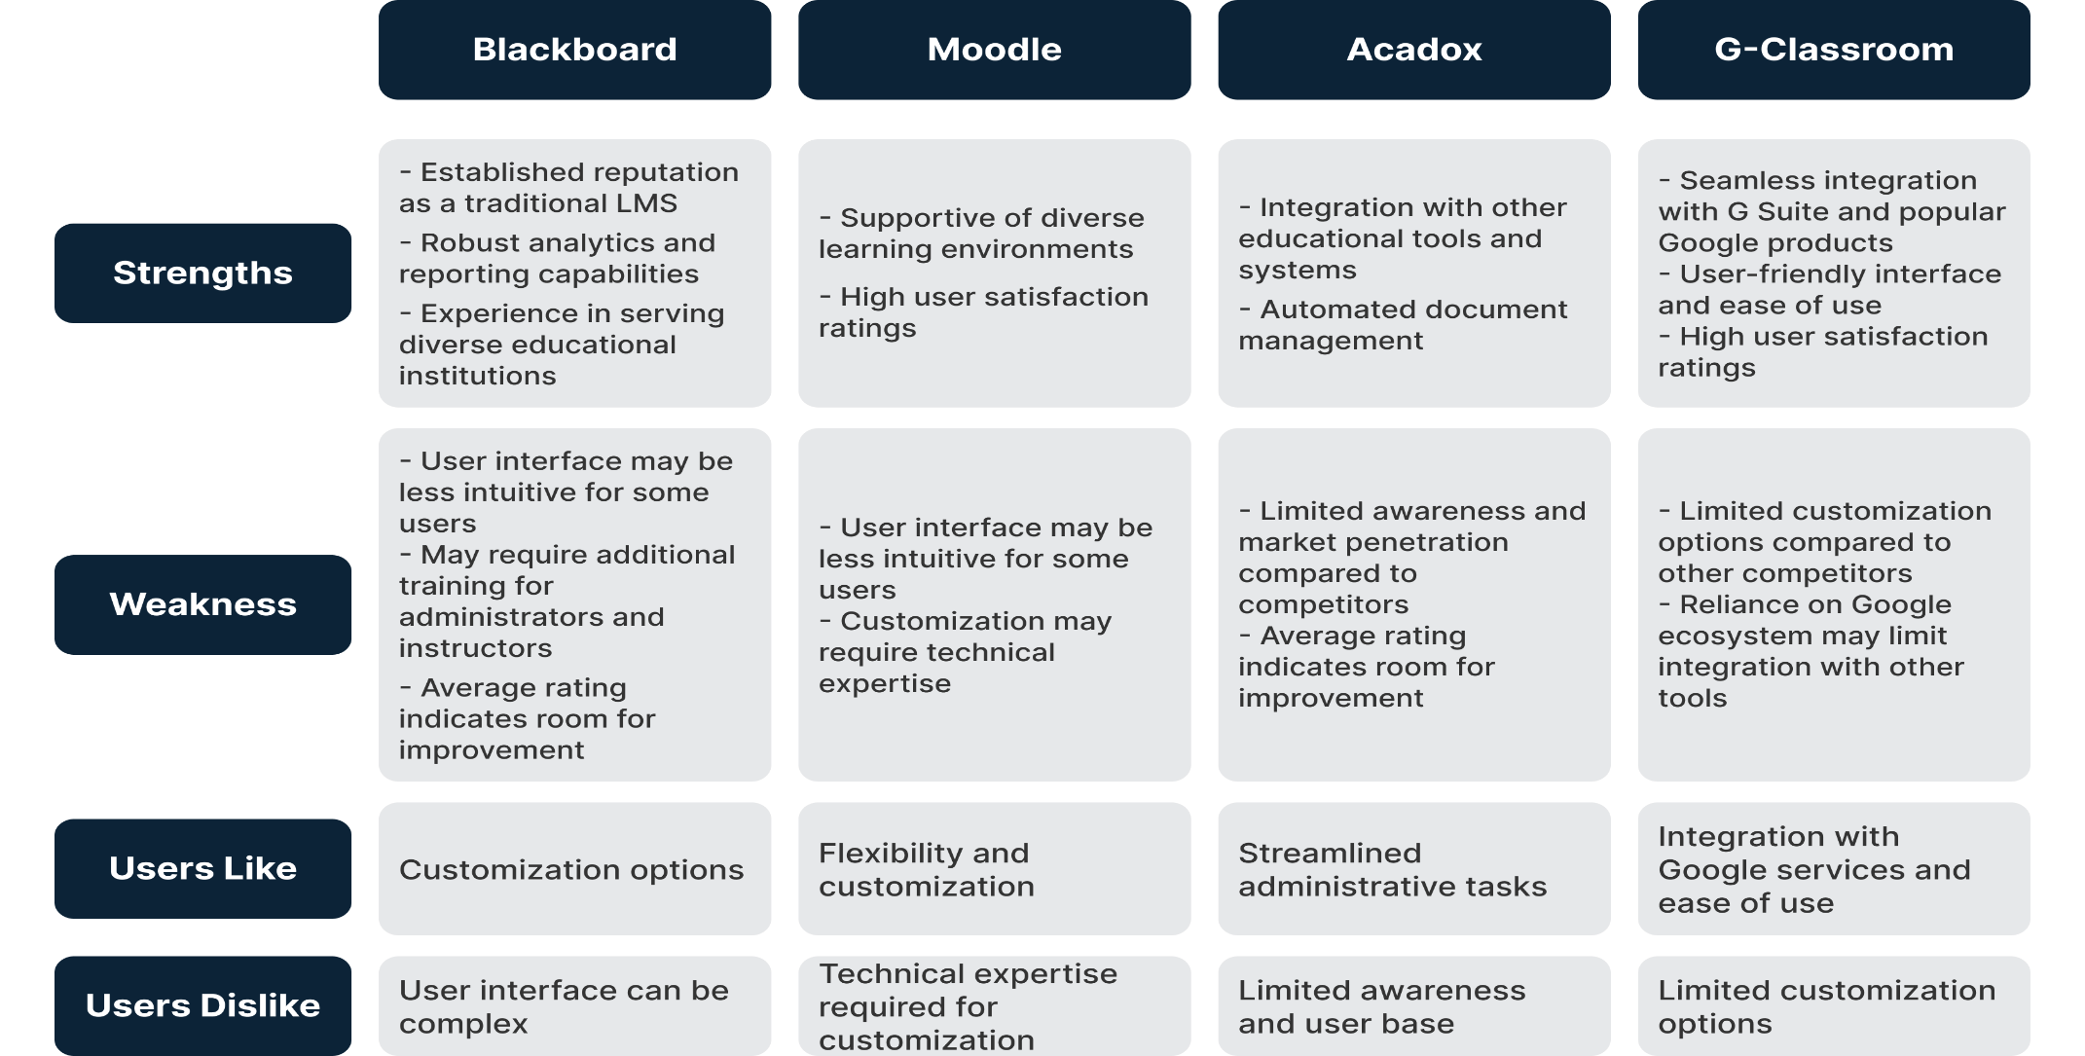

## SWOT Analysis

* Strengths
  + User-centric design, with a focus on providing an intuitive and easy-to-use platform for learners, educators, and management.
  + Advanced analytics and reporting capabilities that enable data-driven decision-making.
  + Support for mobile learning and accessibility features, ensuring that all learners have equal access to the content.
  + Personalized learning paths and adaptive assessments, providing tailored learning experiences for individual student needs and abilities.
* Weaknesses
  + Lack of brand recognition and reputation, which may make it challenging to attract users in a crowded market.
  + The development of advanced features and analytics capabilities may require a significant investment of resources.
  + The platform may require ongoing maintenance and updates to ensure that it remains relevant and up to date.
* Opportunities
  + The growing demand for e-learning platforms due to the COVID-19 pandemic and the increasing importance of online learning.
  + The potential to partner with educational institutions and organizations to promote the platform and attract users.
  + The potential to expand the platform to include additional features or support for other types of education.
* Threats
  + Intense competition from established e-learning platforms that have a strong brand and reputation.
  + The risk of security breaches or data loss, which could undermine user confidence in the platform.
  + Regulatory and compliance issues that may arise when handling sensitive student data.

## Features

Our team aims to create a platform that provides a better user experience and better maintenance and monitoring for educators. We will focus on addressing the shortcomings of other mainstream platforms. A detailed version based on the additional information gained from the survey can be found in Project Preliminary Requirements

### The key features

* Acting as a material repository for students
* Conducting quizzes and tracking grades
* Providing easy-to-use tools for educators to communicate with students and track their progress.
* Advanced analytics and reporting capabilities that provide insight into student performance, course effectiveness, and learning outcomes.
* Support for mobile learning, allowing students to access content and interact with their instructors on their smartphones and tablets.
* Accessibility features, such as closed captioning, text-to-speech, and other assistive technologies to ensure that all learners have equal access to the content.
* Personalized learning paths and adaptive assessments that provide tailored learning experiences based on individual student needs and abilities.

### Leading principals

* + - User-centric design

Our team is committed to creating a platform that is intuitive, easy to use, and meets the needs of our users. We will prioritize user feedback throughout the development process to ensure that our platform is tailored to the needs of modern learners and educators.

* + - Analytics and reporting

Our platform will provide advanced analytics and reporting capabilities that provide insight into student performance, course effectiveness, and learning outcomes. This will enable educators and management to make data-driven decisions and continuously improve the learning experience.

# Chapter 3: Analysis



## Data Gathering

Our vision with this project is to create an LMS that provides an easy and encompassing environment for students, making them not need that many external tools, for teachers to ease their experience and allows them to provide the most value for students with the least effort and for administrators to easily keep track of the courses, performances, and efficiency of their staff. Thus, to help direct our project and provide more concrete steps towards those goals, we conducted 2 surveys with the aim of asking students and teachers about their experiences with LMS, their preferred one, the issues they face, and the features they wish to see.

With that in mind, given how we want both the needs of less-experienced stakeholders like our students and extremely experienced stakeholders like teaching staff, we opted to create 2 different surveys. Though both have the same goal, the student version is more quantitative with some supplementary qualitative questions seeking to collect as much data as possible with most questions being Multiple Option Questions and 5-step Likert scale questions starting from 1 (Strongly disagree) till 5 (Strongly Agree). For Example: “on a scale from 1 to 5. Please rate this” which allows us to analyse their responses and weight them to notice any inconsistencies or repeated sentiments. For the teachers, we tried to focus on qualitative questions given they are both stakeholders we are less familiar with, given we are students ourselves, and due to their years of experience they would have better awareness and expertise dealing with LMS.

## Survey Structure

For ease of use, we chose a commonly used form creation tool which is Google Forms and started creating our questionnaire using scale questions, multiple choices, and open-ended questions. Due to having a good number of foreign students at Cairo University, we decided to include an Arabic or English choice for the students to make sure it can be accessible and easy for students who are still learning Arabic. For a full detailed list of all the questions please refer to the appendix.

## Analysis Steps

To process the data, we received and present it into a proper summary report we used an Excel sheet as it is the format Google form outputs. We got the collected data and proceeded to rearrange it into the staging sheet. We used this step to format the responses in a clearer way and prepare for the analysis stage. For the sake of summarisation, we opted to categorize the responses and analyse the responses for the top 3 LMSs which most people have experience using because it implies that those 3 will also have better-educated responses and suggestions.

As pointed out before the student survey is mostly quantitative questions so analysis of their responses took the form of sorting the numerical data for questions with multiple options getting means for scale questions and then visualizing them using charts to show how each option compares to the others and point out clear user preferences and/or characteristics.

For the qualitative questions, we decided to categorize them based on important elements to the users like speed, ease of use, functionality, etc. And picked the most recurring requests in our report for each major LMS.

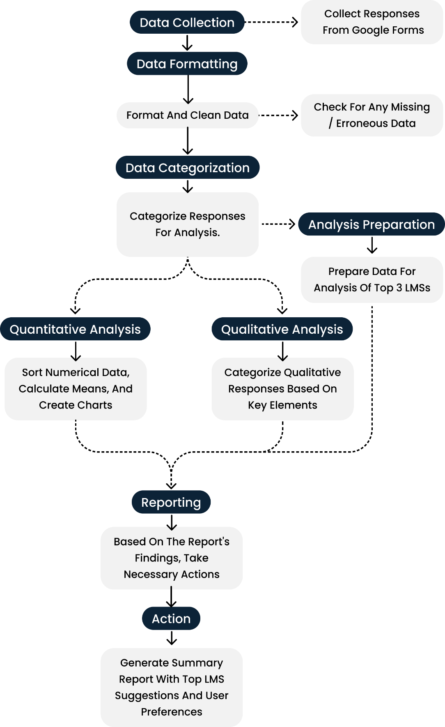

Figure 1Survey Analysis Steps

## Survey Results

Our survey collected 98 responses from students and all extra details can be found in the full report in the appendix. The students were from various faculties though most of them were from Cairo University and in engineering or computer science faculties. Most of them are in their fourth year, in computer science and engineering Faculties, and have used an LMS before(95.6%) which is reflected in Figure 18 Survey Faculty Chart, Figure 17 Survey University Chart*,* and Figure 16 Survey University Year Chart

Though the sample size is small, some helpful insights can be gained from the quantitative results alone, as 56.3% said they use both mobile and Web apps and 6.3% rely fully on the LMS mobile app which points out the importance of having an accessible and easy to use mobile application.

The answers to question 8 on the students' survey (how often do you use the LMS) are a bit inconclusive as 40.5% of the respondents said they use it daily and 36.7% said they rarely use it which points out the variance of how students approach using an LMS and using external tools or other sources to study like YouTube.

But most important is the usage data on which LMS the students preferred here Figure 21 Survey Preferred LMS Chart. Which shows that Blackboard, Google Classroom, and Microsoft Teams are the top three choices for LMS.

On the top is the chart representing the percentages of which LMS the students preferred (Question 7) while below are the cumulative numbers of which LMS the students ever used (Question 6)

It is also crucial to point out a few major points that are derived from this data.

* Firstly, even though Microsoft Teams is not an LMS in the strictest terms, its features of organizing work, dashboards, sharing material and video streaming made it a very useful tool for students and teachers alike.
* Secondly, an interesting note to point out is that 100% of the respondents who chose Blackboard as their preferred LMS were all from Cairo University, adding the fact that most respondents are from Cairo University suggests that the current features of Blackboard are liked enough to warrant a second place even when no other student from another university chose Blackboard.
* Thirdly, this also warrants a deeper look into Google Classroom, as though compared to Blackboard it lacks a lot of the features that allow Blackboard to be an internationally recognized LMS, it is still preferred by many students.
* Lastly, following up on the previous point, even though we added other internationally recognized LMSs like Canvas and Moodle, barely anyone preferred them or even used them. This can be due to our limited respondents, but it can also imply a lack of experiments with those LMS in higher education in Egypt.

Figure 20 Survey LMS Cumulative Usage Chart

For the teachers' survey sadly we only received 6 responses which is an inadequate number to do a proper data-driven analysis. However, given how most of the questions were qualitative, we can simply screen the responses manually instead of doing deep analysis and categorization.

By going through the responses some common points were made by the teaching staff on how important Ease of use, reusability, of course, issues caused by low bandwidth, sharing and organizing files easier, making quizzes and lastly video conferencing.

## Project Preliminary Requirements

Per the previous Analysis results, we created a list of requirements/features that should be apparent and focused upon in the project design phases as they can be considered our initial goals and main features till further improvements and adaptations happen. For a full detailed list with explanations for each item please refer to the appendix. The list is split into 3 categories based on priority/importance/Ease of implementation, Those 3 categories.

* Must Have Features: Features that are crucial to the LMS and should not pose significant trouble implementing.
* Should Have Features: Features that include quality-of-life improvements or minor additions to the system as a whole and their implementation may need consideration in the design phase or are easy to implement.
* Nice To Have Features: Features that can benefit stakeholders but are not crucial and their implementation may be extremely complicated and/or require extreme hardware capabilities.

### Must Have Features:

* User Dashboard
* Tracking Course Progress
* Cloud Storage
* Multi-language support ability
* Communication Features
* User-Friendly and easy to navigate Interface.
* Accessible interface
* Hot Keys/Quick Access to Tools
* Labels and Categorisation/Platform Organization
* Self-Enrolment with invitations or codes
* Create Courses
* Add Material/Reuse material from other courses.
* Tasks/Assignments
* Writing/Post Editor page
* Quiz assignments
* Mobile App Availability
* Fast Performance
* Blog per Course

### Should Have Features:

* Dark Mode Option
* YouTube video Integration
* SCROM/Xapi/Inter-operability Conformance
* Enhanced Search Tools
* Customizable Settings
* Direct File Downloads
* Tutorials
* Advanced (reply to and set reminders, etc) Notifications.
* File Management System
* Integrated External Resources
* Assessment Tools (Scoring) /Teacher Dashboard
* Feedback Mechanisms
* In-depth Analytics

### Nice to Have Features:

* Live Meeting Functionality
* Personalized Learning Paths
* Collaborative Features/ Student teams and shared scores
* Auto-grading (Text recognition)

### Functional requirements:

1. **User Authentication**

* User initiates registration by providing details and system validates.
* User logs in using credentials or third-party accounts.
* User resets the password if forgotten.

1. **User Actions**

* Students enrolled in courses, access content, and track progress.
* Teacher creates/updates/reviews/deletes assignments, materials, quizzes, and courses.

1. **Platform Features**

* User uploads, downloads, and manages learning materials.
* Users set preferences for language (AR, En), accessibility (screen light, colour blind palette), and appearance (Font size, font format, dark/light modes).

1. **Course Management**

* Admin generates enrolment codes and controls courses.
* Student self-enrols using provided codes.

1. **User Settings**

* User updates profile, manages preferences, and data.

1. **Feedback and Assessment**

* Users provide feedback, ratings, and engage in assessments.

1. **Mobile App and Accessibility**

* Users access the platform via mobile app with optimized design.
* User utilizes accessibility features.

1. **Admin Functions**

* Admin manages users, courses, platform, and configurations.

1. **Reports and Analytics**

* Admin reviews reports and analytics for decision-making.

1. **User Support and Maintenance**

* Admin supports users and oversees platform maintenance.

### Non-functional:

**Usability**:

* **Accessibility**: Ensure compliance with accessibility standards (e.g., Web Consortium Accessibility Guidelines WCAG) to make the LMS usable for individuals with disabilities.
* **User Experience (UX**): Define guidelines for the overall user experience, such as intuitive navigation, consistent layouts, and responsive design.

**Performance:** To ensure speed and Efficiency, the actual system will be built with low-resource servers in mind and the front-end will be made with platform-specific technology to ensure efficiency. By relying on scalable hosting services like Amazon Web Services (AWS), or ORACLE to scale for more customers. and use a microservices architecture to enable scalability, near 100% uptime, and easy integration of new features.

**Reliability:** Reliability is concerned with ensuring our services go down as little as possible, this can be done by ensuring our code robustness and how it deals with errors and using high-quality services to manage the servers. So, it can handle a few thousand students connecting concurrently to the servers, a similar size to an Egyptian University student count per faculty, so around 2000 concurrent requests.

## User Research

### Background

The E-Learning Platform project is a critical educational tool that supports students, teaching staff, and student management professionals. Its success is dependent on its ability to meet the evolving needs and preferences of its users. To ensure its effectiveness, a user-centred approach was adopted to enhance the user experience.

### Objectives

**The primary objectives of this user-centred approach were:**

* Identify challenges and pain points experienced by users.
* Determine essential features and tools that users require for an optimal experience.
* Gather user preferences and suggestions for platform improvement.



### Research Methods

To achieve the objectives, a mixed-methods approach was employed, combining qualitative user interviews and quantitative online surveys. This allowed for a comprehensive understanding of user perspectives.

### Participant Recruitment

Participants were recruited through various channels, including online platforms, educational institutions, and social media groups. A diverse group of users was involved, including students, teaching staff, and student management professionals.

### Data Collection

**Data was collected through:**

* **Semi-structured Interviews:** Conducted remotely via video conferencing, these interviews provided in-depth insights into user experiences.
* **Online Surveys:** Structured questionnaires in the form of online surveys gathered quantitative data from a larger user base.

### Student Users Profiles

* Undergraduate and graduate students
* Varying levels of technological proficiency
* Seeking efficient access to course materials and effective communication tools

### Teaching Staff Users Profiles

* Professors and educators with extensive teaching experience
* Adapting to online teaching methods
* Focused on content creation, interaction, and analytics.

### Student Management Users Profiles

* Student managers overseeing various aspects of student affairs.
* Focused on data management, communication, and event coordination.

### Dashboard Design

* Create an intuitive and user-friendly dashboard that provides efficient access to course materials.
* Ensure that the dashboard is customizable, allowing users to personalize their learning space.
* Implement a robust notification system for timely updates on new content, announcements, and assignment due dates.

### Content Formats and Customization

* Support a variety of file formats, such as PDFs, videos, and interactive simulations, to cater to different learning preferences.
* Provide customization options, allowing users to personalize their learning experience, including the arrangement of courses and resources.

### Communication and Collaboration

* Implement robust communication tools, including announcements, discussions, and virtual office hours.
* Develop collaboration tools that enhance group work and peer-to-peer communication, fostering a sense of community.

### Accessibility and User-Friendliness

* Prioritize accessibility and user-friendliness, ensuring that the platform accommodates users with varying levels of technological proficiency.

## User Persona

Persona 01: Doaa - The Undergraduate Student

**User Persona Details**

Name: Doaa

Age: 21

Background: Doaa is an undergraduate student majoring in Computer Science. She's in her third year at the university. She's tech-savvy and comfortable with various online tools and platforms. Her primary goal is to excel in her studies.

**User Stories for Doaa**

* User Story: As Doaa, I want to be able to access course materials, including lecture notes, slides, and assignments, from a user-friendly dashboard. This way, I can quickly find what I need for my coursework.
* User Story: As Doaa, I want the platform to support various file formats, like PDFs, videos, and interactive simulations, to cater to different types of of course content.
* User Story: As Doaa, I want the ability to customize my dashboard, so I can prioritize my most important courses and resources.
* User Story: As Doaa, I want to receive notifications for new content, announcements, and upcoming assignment due dates to stay on top of my coursework.
* User Story: As Doaa, I want a collaborative workspace where I can work on group projects with my peers efficiently.

**Empathy Map for Doaa**

**What Doaa Says**

* "I often find it challenging to locate the materials I need for my courses."
* "I wish there was a way to stay updated on my assignment due dates and course announcements."
* "I like having options for customizing my learning space."

**What Doaa Does**

* Doaa spends a lot of time searching for lecture materials.
* She frequently checks her email for course updates.
* She tries to organize her study environment to minimize distractions.

**What Doaa Thinks and Feels**

* Doaa feels overwhelmed when materials are disorganized.
* She worries about missing important announcements.
* She enjoys personalizing her learning experience.

**Doaa's Pain Points**

* Difficulty finding course materials quickly.
* Anxiety about missing important updates.
* Feeling overwhelmed by a cluttered dashboard.

**What Doaa Gains**

* More efficient access to study materials.
* Reduced stress through better communication.
* A sense of control and focus in her learning.

By understanding Doaa's persona, needs, and pain points, an e-learning platform can be developed or improved to cater to her specific requirements, making her learning experience more efficient and enjoyable.

Persona 02: Hassan - The University Professor

**User Persona Details**

Name: Hassan

Age: 42

Background: Hassan is a university professor with over 15 years of teaching experience in the field of Computer Engineering. He's well-versed in traditional teaching methods and is adapting to online education. His primary goal is to engage and educate his students effectively.

**User Stories for Hassan**

* User Story: As Hassan, I want an intuitive content creation tool that allows me to design engaging and interactive online lectures and course materials.
* User Story: As Hassan, I need a platform that supports live video streaming and virtual classroom features for conducting real-time interactive sessions with my students.
* User Story: As Hassan, I'd like a robust discussion forum to encourage student participation and facilitate peer-to-peer learning.
* User Story: As Hassan, I want to be able to track student progress and engagement through analytics to adapt my teaching methods for better outcomes.
* User Story: As Hassan, I need easy integration with the university's grading system and a feature for securely sharing grades and feedback with students.

**Empathy Map for Hassan**

**What Hassan Says**

* "Online teaching tools should be as user-friendly as traditional classroom materials."
* "I need a platform that makes it easy for students to ask questions and participate in discussions."
* "Analytics on student engagement can help me identify struggling students and provide timely support."

**What Hassan Does**

* He spends time creating course materials and lectures.
* He encourages student participation through discussions and assignments.
* He uses analytics to assess student progress.

**What Hassan Thinks and Feels**

* Hassan values effective teaching methods.
* He feels the need to adapt his teaching style to online platforms.
* He wants to foster a sense of community and engagement in his virtual classroom.

**Hassan's Pain Points**

* Difficulty in creating engaging online content.
* Limited interaction and engagement in virtual classrooms.
* Challenges in identifying struggling students.

**What Hassan Gains**

* Enhanced teaching materials and methods.
* Increased student engagement and participation.
* Better support for struggling students through analytics.

Understanding Hassan's persona, pain points, and needs can help in designing an e-learning platform that empowers professors like him to provide high-quality education in the online environment. This persona can guide the development of features and tools tailored to the unique requirements of teaching staff.

Persona 03: Kareem - Student Manager / Management Staff

**User Persona Details**

Name: Kareem

Age: 35

Background: Kareem works as a student manager at a university, overseeing various aspects of student affairs. He's responsible for ensuring a smooth and efficient learning environment for both students and teaching staff.

**User Stories for Kareem**

* User Story: As Kareem, I need a comprehensive dashboard that provides an overview of student enrollment, attendance, and performance data to make informed decisions.
* User Story: As Kareem, I want to be able to communicate with students and professors effectively through the platform to address any administrative issues or concerns.
* User Story: As Kareem, I require a feature that allows me to schedule and manage online meetings, workshops, and events for students and teaching staff.
* User Story: As Kareem, I need access to data analytics and reports that help me identify trends, improve student retention, and optimize course offerings.
* User Story: As Kareem, I want a secure and efficient system for managing student records, including enrollment, grades, and course schedules.

**Empathy Map for Kareem**

**What Kareem Says**

* "I need quick access to up-to-date information on student enrollment and performance."
* "Communication with students and professors should be seamless to address issues promptly."
* "Data analytics can help us understand and improve student outcomes."

**What Kareem Does**

* He regularly reviews data and reports on student enrollment and performance.
* He communicates with students and professors to resolve administrative matters.
* He uses data analytics to inform decision-making.

**What Kareem Thinks and Feels**

* Kareem aims for efficient management of student affairs.
* He wants to provide support and resources for student success.
* He feels that data-driven insights are critical for making informed decisions.

**Kareem's Pain Points**

* Inefficient access to student data and communication tools.
* Difficulty in managing administrative tasks without proper features.
* The challenge of identifying and addressing student performance issues.

**What Kareem Gains**

* Streamlined access to critical student data and communication tools.
* Improved administrative efficiency and the ability to support student success.
* Informed decision-making and better student outcomes through data analytics.

Understanding Kareem's persona and the challenges he faces in managing student affairs can guide the development of an e-learning platform with administrative features that empower professionals like him to enhance the overall educational experience and student support services.

## *Use Casses*

1. **Admin Creates User Account**

* Admin Creates a new user account with user Email and ID
* It Auto Generates a random password for the account

1. **User Logins**

* User clicks on the "LogIn" button.
* User enters their registered College ID/email and password.
* System validates the entered credentials.
* If valid:
* Users gain access to their account and the platform.
* If invalid:
* System displays an error message.
* User has the option to reset the password or contact support.

1. **User Resets Password**

* User clicks on the "Forgot Password" link.
* User is prompted to enter their registered email address.
* System verifies the email address's existence in the database.
* If the email is valid:
* System sends a password reset link to the user's email.
* User receives the email and clicks on the reset link.
* User is redirected to a page where they can create a new password.
* User enters a new password and confirms it.
* The system updates the user's password.
* User can now log in with the new password.
* If the email is not valid:
* System displays an error message.
* User is prompted to re-enter their email address.

1. **Teacher Adds Assignment**

* Teacher logs into their account.
* Teacher accesses the specific course where they are the instructor.
* Teacher navigates to the assignment creation section.
* Teacher provides assignment details, including title, description, and due date.
* Teacher sets assignment parameters, such as maximum points.
* Teacher creates the assignment.
* The system notifies enrolled students about the new assignment.

1. **Student Submits Assignment**

* Students log into their account.
* Students access the course where they have an assignment.
* Student navigates to the assignment submission section.
* Students upload their assignment file or enters text.
* Student submits the assignment.
* The system records the submission and notifies the Teacher.

1. **Student Checks Course Grades**

* Student logs into their account.
* Student accesses the course.
* The system displays the quizzes and assignments’ grades for this specific courses

1. **Student Labels and Categorization/Platform Organization**

* System must organize content with clear labels, categories, nested folders, and efficient tagging systems for easy resource discovery.

1. **Student Self-Enrolls with Codes**

* Student receive the enrollment code and logs into their account.
* Student navigates to the "Enroll in a Course" section.
* Student enters the enrollment code provided by the teacher.
* System verifies the code's validity.
* If the code is valid:
* Student is successfully enrolled in the course.
* System adds the course to the student's enrolled courses.
* If the course is not full:
* Student can now access the course content.
* If the course is full (maximum enrollment reached):
* System displays a message indicating that the course is full.
* Student can join a waiting list if available or choose another course.
* If the code is invalid or expired:
* System displays an error message.
* Student has the option to re-enter a valid code.

1. **Admin Creates Courses**

* Adminlogs into their account.
* Adminaccesses the course creation section.
* Adminprovides course details, including title, image, description, code, enrolment code, and assigned teachers.
* Admincreates the course.
* The system makes the course available to enrolled students.

1. **Teacher Adds/Reuses Material**

* Teacher logs into their account.
* Teacher navigates a course he previously given and goes to a specific post
* Teacher can reuse the post details by clicking a button.
* Teacher will choose another course and go to their post creation page with all the data prefilled with the older post data

1. **Teacher Adds Quiz**

* Teacher logs into their account.
* Teacher accesses the course where they want to create a quiz.
* Teacher creates a new quiz with questions, including text, multiple-choice.
* Teacher configures the Grade of each question.
* Teacher configures grading options (automatic or manual).
* Teacher configures the time for the quiz.
* Teacher publishes the quiz for students.
* The system notifies enrolled students about the new quiz.

1. **Student Submits Quiz**

* Student logs into their account.
* Student accesses the course with a quiz assignment.
* Student takes the quiz, answering questions.
* Student submits the quiz.
* System grades the quiz automatically (if configured) or awaits manual grading by the instructor.
* The system records the submission and notifies the Teacher.

1. Teacher Grades Quiz

* Teacher can access a certain Quiz by going to the course home page and checking the quiz menu
* Upon selecting the desired quiz and accessing its page, he will find a tab where a list of all students in this course will be provided with their submission status
* He can select a submission where he will go through each question and that students answer manually and select whether it is correct or not

1. Student Checks Pending deadlines:

* Student can either Enter a course home page and check the quizzes and assignment sections
* Alternatively the student can access the calendar page where all upcoming dates for pending tasks will be shown

1. Teacher Creates Post

* Teacher can Enter any course home page where he has privilege to post and simply access the post creation area
* He must add a title and description for the post
* He can Add a schedule date, a poll, and materials to the post

1. **Teacher Integrates YouTube Video**

* Teacher logs into their account.
* Teacher accesses the course where they want to include a YouTube video.
* When teacher creates a post they can paste a YouTube link inside the post description and it will get pasted into an embed automatically
* System validates the URL and fetches the video details.
* System adds the YouTube video in the course content.

1. **User Accesses Settings**

* Users can access their account settings by clicking on their profile picture or username.
* Within the user settings section, users can customize various aspects of their platform experience, including:
* **Profile Information:**
* Users can update their profile picture.
* Users can edit their name, bio, or other personal details.
* **Privacy Settings:**
* Users can configure privacy settings for their profile, such as who can view their profile and contact them.
* **Notification Preferences:**
* Users can manage their notification preferences, including email notifications, course updates, and announcements.
* **Language Preferences:**
* Users can select their preferred language for the platform's interface.
* **Theme Selection:**
* Users can choose between different themes (e.g., light mode, dark mode) for the platform's appearance.
* **Accessibility Settings:**
* Users can enable or customize accessibility features, such as text-to-speech or high-contrast mode.
* **Security Settings:**
* Users can update their password or enable two-factor authentication for added security.
* **Email Preferences:**
* Users can specify their email communication preferences, such as newsletter subscriptions.
* **Data Management:**
* Users can access tools to manage their data, including downloading their course materials and personal information.
* Users can save their settings, and the platform will apply the changes accordingly.

1. **Student Feedback Mechanisms**

* System must allow learners to provide feedback on courses, content, and the platform itself through surveys, ratings, and open forums.

1. **Assessment Tools/Teacher Dashboard**

* System must offer assessment tools for instructors to design and administer quizzes, assignments, and assessments.
* System must provide automated grading, feedback mechanisms, course modifications, and course analytics to teachers.

1. **Student Downloads Materials**

* Students logs into their account.
* Students accesses the course for which they want to download materials.
* Students navigates to the "Course Materials" or "Resources" section of the course.
* Students locates the specific material they want to download (e.g., a document, video, presentation).
* Students clicks on the material to download it.
* Students selects the download location and confirms the download.
* The system initiates the download process.

1. **Admin Manages User**

* The Admin can view a list of all users registered on the platform.
* The Admin can search for specific users based on criteria such as name, email, or role (Teacher, Student, etc.).
* The Admin can access individual user profiles to view and edit their information.
* The Admin can reset passwords for users or force password changes.
* The Admin can deactivate or suspend user accounts if necessary.
* The Admin can reactivate previously suspended accounts.

1. **Admin Manages Courses**

* The Admin can view a list of all courses offered on the platform.
* The Admin can modify or delete courses.
* The Admin can assign or change instructors for courses.
* The Admin can monitor course enrollment and view enrollment statistics.
* The Admin can set course enrollment limits.
* The Admin can archive or temporarily hide courses.
* The Admin can review and approve/disapprove course content created by teachers.

1. **Teacher Assigns Roles and Permissions**

* The Teachercan define and manage user roles and permissions.
* The Teachercan create custom user roles with specific permissions.
* The Teachercan assign roles to users or groups of users.
* The Teachercan revoke or modify permissions for specific users or roles.
* The Teachercan track changes to roles and permissions.

1. **Admin Reviews Reports and Analytics**

* The Admin can access comprehensive reports and analytics on user activity, course engagement, and platform usage.
* The Admin can use analytics to identify trends, areas for improvement, and potential issues.

1. **Admin Supports User**

* The Admin can provide support to users, including responding to inquiries and troubleshooting issues.
* The Admin can access a support ticketing system to manage and resolve user-reported problems.

1. **Admin Manages Platform Maintenance and Updates**

* The Admin can schedule and perform routine maintenance tasks, including updates and backups.
* The Admin can ensure the platform remains up-to-date with the latest security patches and features.

## Use Case Diagram

Figure 2 User use case diagram

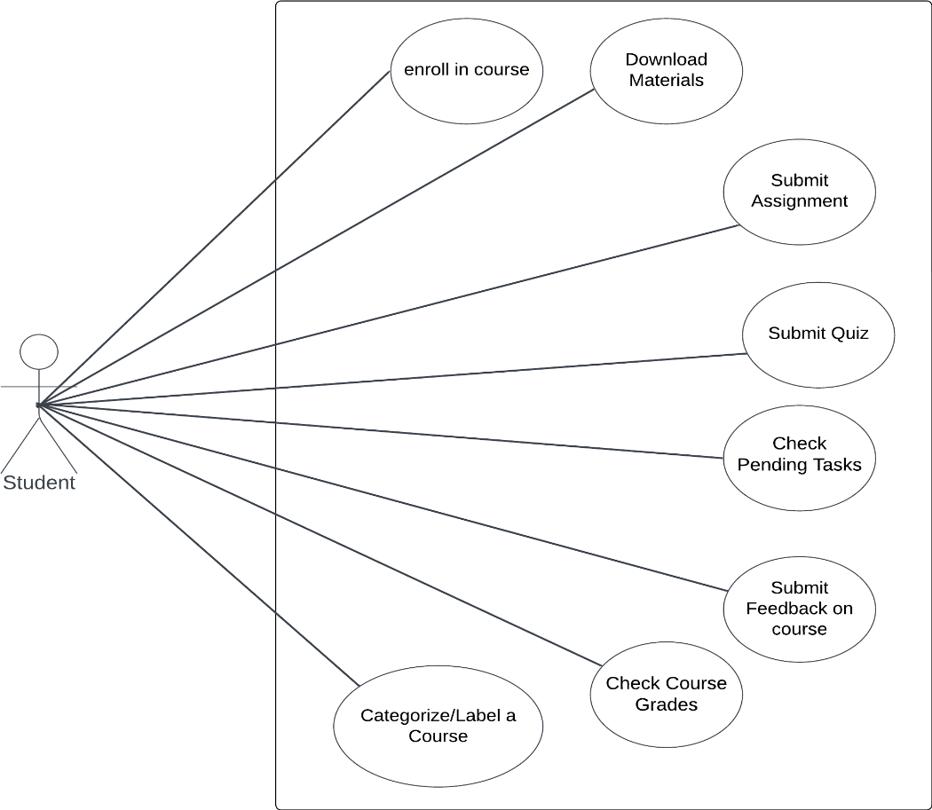

Figure 3 Student use case Diagram.

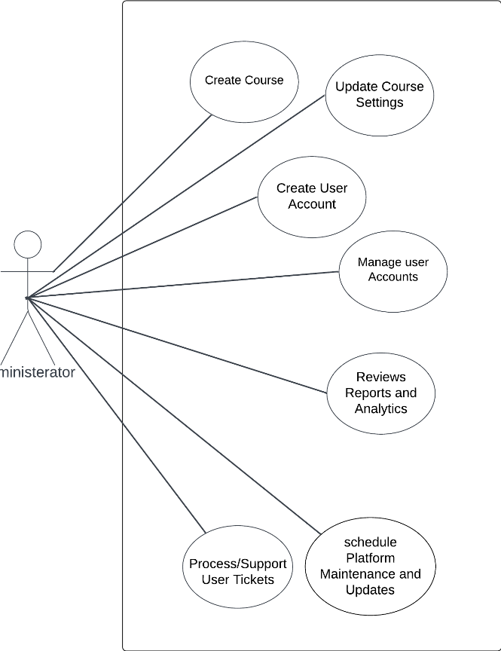

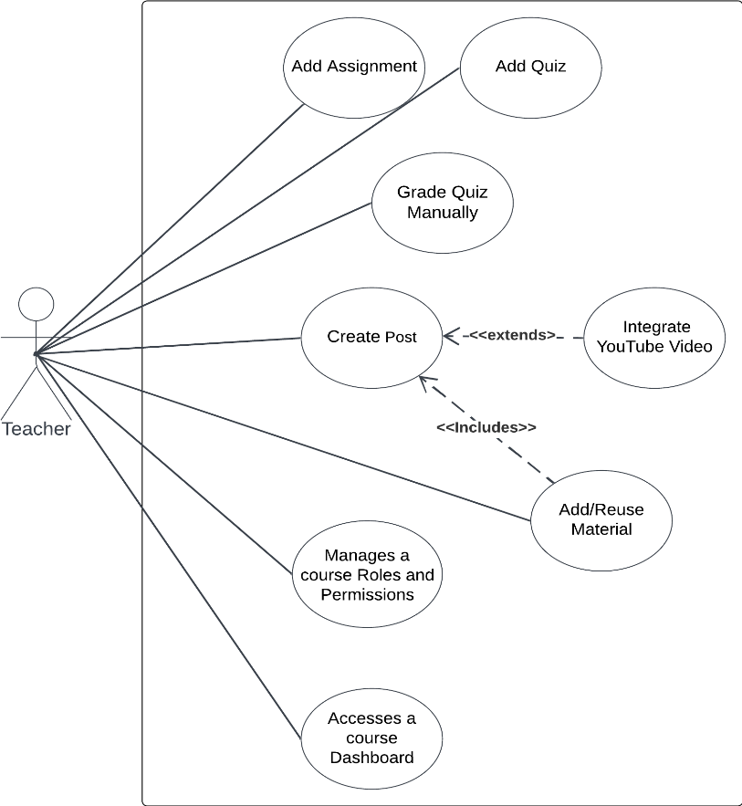Figure 4 Administrator use case Diagram.

Figure 5 Teacher use case Diagram.

## Use Case Descriptions

**1: User Logins**

Table 3 Use Case Description 1

| Use case ID | Case 2 | |
| --- | --- | --- |
| Use Case Name | User Login | |
| Actors | Student, teacher, Admin | |
| Pre-condition | User is registered. | |
| Post-condition | User is logged into the platform. | |
| Flow of events | User Action | System Action |
| 1. Users enter their registered email and password. |  |
|  | 1.1. System validate the entered credentials. |
| Exception scenario | Invalid login credentials. | |

**2: Student enrolls in Course:**

Table 4 Use Case Description 2

| Use case ID | Case 4 | |
| --- | --- | --- |
| Use Case Name | Course Enrollment | |
| Actors | Student | |
| Pre-condition | Student is logged into their account. | |
| Post-condition | Student is enrolled in the course and can access course content. | |
| Flow of Events | User Actions | System Actions |
| 1. Student navigate to the course catalog or search feature. |  |
|  | 1.1. System display the course to the student |
| 2. Student enter enrollment code or invitation link |  |
|  | 2.1. System enroll the student in the course |
| Exception scenario | Course code or invitation link is not valid Or Course is at maximum enrollment capacity. | |

**3: Teacher Add Assignment:**

Table 5 Use Case Description 3

| Use case ID | Case 5 | |
| --- | --- | --- |
| Use Case Name | Assignment Creation | |
| Actors | Teacher | |
| Pre-condition | Teacher is logged into their account and accesses the course. | |
| Post-condition | Assignment is created and students are notified. | |
| Flow of Events | User Actions | System Actions |
| 1. Teacher provide assignment details, including title, description, and due date. |  |
|  | 1.1. The system notify enrolled students about the new assignment. |
| 2. Teacher create the assignment. |  |
| Exception scenario | None | |

# 

# Chapter 4: Design



## Architecture

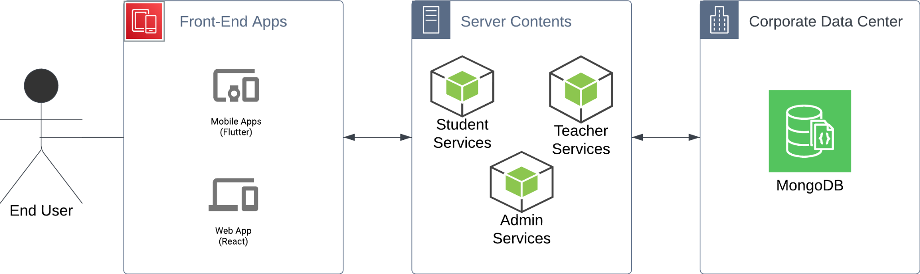

Figure 6 high-level architecture.

For Academia, the System will be split into a simple MVC (Model View Controller) architecture with some minimalistic microservices architecture. The three main modules are independent of each other and are based on XAPI (Experience Application programming interface) guidelines.

* Front-end Applications would have their own hosting server that is independent of the other modules and both simply serve as the interface to receive the data from and manage data that may be on the client side (cookies, downloadable data, upload-able files)
* On the Server The technology utilised will be Node.js Express servers as our objects are JSON-based and databases are document-based, Node.js will provide more functionality and speed to manage our data efficiently. Each stakeholder will have access or their own service which will help separate important computing resources. A teacher would not use their services as much as a student so their services can receive less computing power, while an admin analytical service may cause a big load on the servers.
* The Database technology will be MongoDB-based as a NoSQL database will be more suitable for the specification by the XAPI guidelines and allows for easier scalability.

Given the requirements of Academia and the stated above architecture, Special attention should be given to the database schema to save different kinds of files and to specific features like language compatibility and client-side management of files.

## Class Diagram

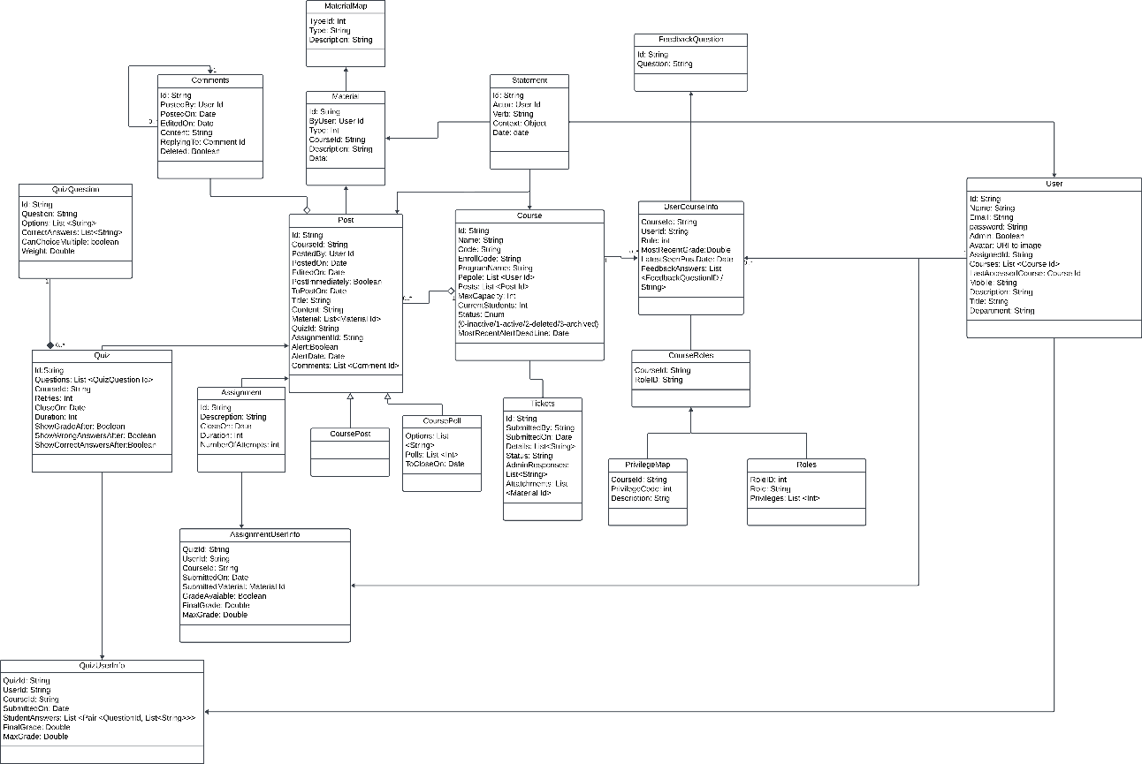

Figure 6 Class diagram

## BPMN Diagrams

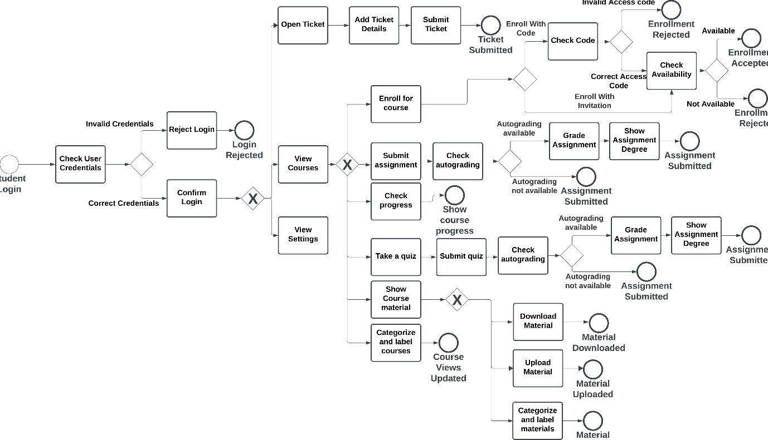

Figure 7 Student BPMN Diagram

Figure 8 Teacher BPMN Diagram

## Sequence Diagrams

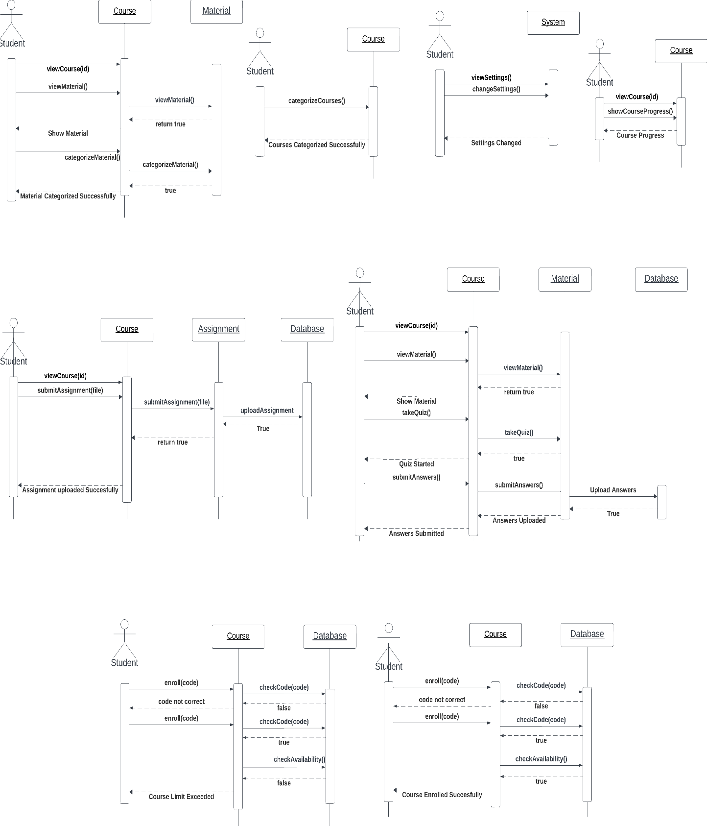

Figure 9 Student Sequence Diagrams

## User Interface Screens

Figure 10 Home | Filled State

Figure 11 Add Course

Figure 12 Login | Empty State

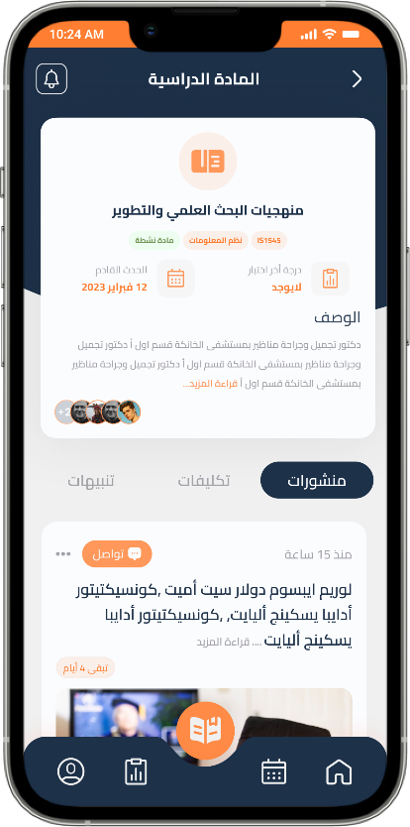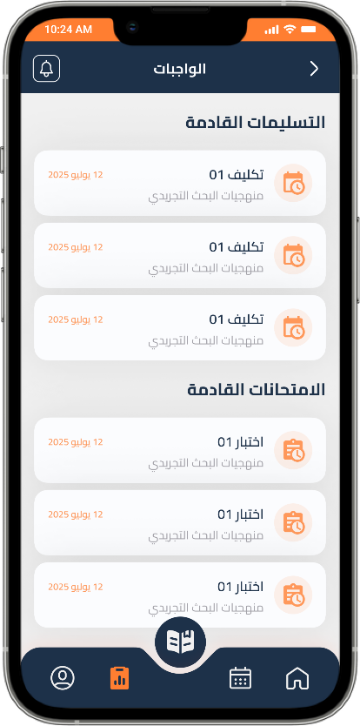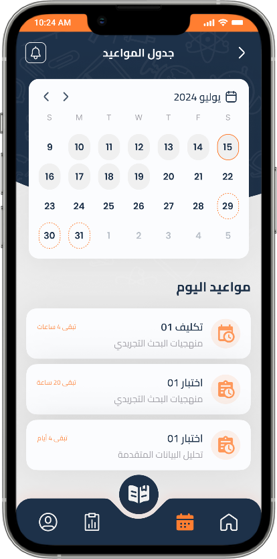

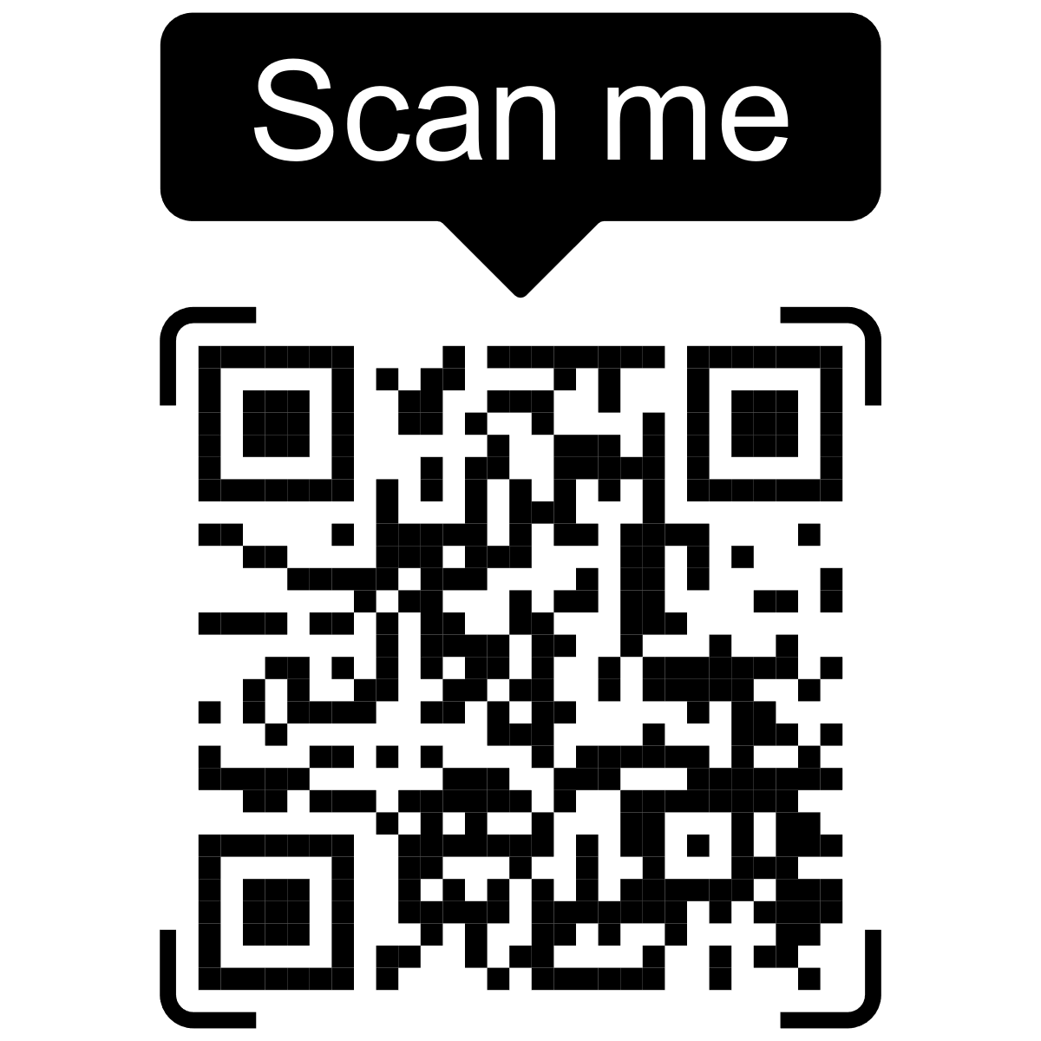

Figure 13 Single Course

Figure 14 Quizzes List

Figure 15 Calendar.

# Appendix

## Competitor Analysis

For the full transcript please refer to the Appendix folder attached to this document, a high-quality PDF of the analysis table should exist there.

## Student Survey

For the full transcript please refer to the Appendix folder attached to this document, a PDF Form of the survey should exist there.

## Teacher Survey

For the full transcript please refer to the Appendix folder attached to this document, a PDF Form of the survey should exist there.

## Use Case Descriptions

For the full transcript please refer to the Appendix folder attached to this document, a PDF Form of the survey should exist there.

## Use Case Diagrams/BPMN/Sequence diagrams/ERD

For the full Detailed diagrams please refer to the Appendix folder attached to this document, a PNG Form of the diagrams should exist there.

## Responses and data analysis

For the full transcript please refer to the Appendix folder attached to this document, an excel sheet with the results and analysis steps should exist there.

## Students Survey Statistics Results:

For the full transcript please refer to the Appendix folder attached to this document, an excel sheet with the results and analysis steps should exist there under “Students Form Statistics”.

Total Participants: 98

General Info “Quantitative”

1. In which language would you like to view the form questions?

Figure 16 Survey Language Chart

1. What is your current university year?

Figure 17 Survey University Year Chart

1. What university are you currently attending?

Figure 18 Survey University Chart

1. What is your faculty or area of study?

Figure 19 Survey Faculty Chart

1. Have you ever used any online learning platform during your university studies?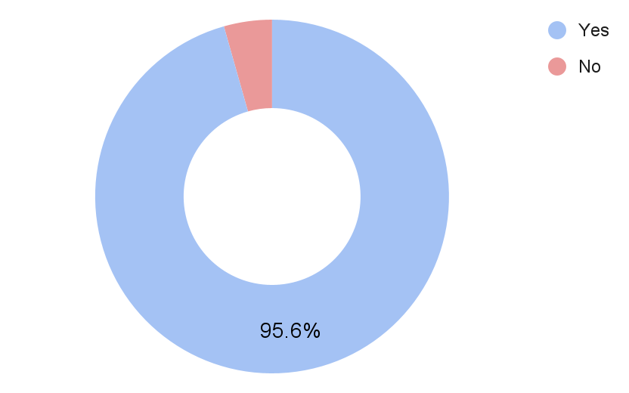

Figure 20 Survey LMS Previous Usage Chart

Usage of E-Learning Platforms in Higher Education

1. Please specify the platforms you have used ( you can select multiple platforms based on your personal usage ).

Figure 21 Survey LMS Cumulative Usage Chart

1. Among these platforms, please select the platform that you prefer to use primarily.

Figure 22 Survey Preferred LMS Chart

### Blackboard Learn

1. On a scale of 1 to 10, rate your overall experience with the platform?

* Based on the responses, the ratings range from 4 to 10, with an average rating of approximately 7.8.

1. Could you briefly explain the reason behind your rating choice?

* Based on the provided explanations for the ratings of Blackboard Learn, here is a summary of the reasons behind the rating choices:

Positive aspects:

* Blackboard Learn allows for uninterrupted lectures and provides the option to save recorded lectures.
* The platform is comprehensive and consolidates course content in one place.
* It is user-friendly and easy to navigate.
* It offers features such as meetings, grades, and exams.
* It is stable, easy to use, and has integrated features.
* It helps in organizing educational materials and recorded lectures.
* It saved a significant amount of time and facilitated learning.

Negative aspects:

* The user interface (UI) can be complex or messy for some users.
* There are occasional technical issues during online quizzes.
* Some desired functionalities are missing.
* It may be unavailable or restricted to specific universities.
* It can be clunky or difficult to use at times.
* There were complications with streaming and curriculum collection.

Some students experienced problems during enrolment due to codes or restrictions.

SWOT Analysis for Blackboard Learn:

Strengths:

* Uninterrupted lectures and the option to save recorded lectures.
* Comprehensive platform that consolidates course content in one place.
* User-friendly interface and easy navigation.
* Offers essential features like meetings, grades, and exams.
* Stable, easy to use, and integrated features.
* Aids in organizing educational materials and recorded lectures.
* Saves time and facilitates learning.

Weaknesses:

* Complex or messy user interface for some users.
* Occasional technical issues during online quizzes.
* Missing desired functionalities.
* Limited availability or restrictions to specific universities.

Opportunities:

* Addressing the user interface issues to improve overall user experience.
* Resolving technical glitches and enhancing platform performance.
* Incorporating additional features to meet diverse educational needs.
* Expanding availability to reach a broader user base.

Threats:

* Competition from other e-learning platforms.
* Negative user experiences leading to reduced adoption.
* Technological disruptions impacting platform usability.

1. On a scale of 1 to 5, rate the performance and speed of the platform.

* Based on the responses, the ratings range from 2 to 5, with an average rating of approximately 3.5.

These ratings suggest that the majority of students perceive the performance and speed of the platform as satisfactory, with some room for improvement.

Understanding the user perception of the platform's performance and speed helps in identifying areas that may require optimization to ensure a smoother and more efficient user experience.

1. On a scale of 1 to 5, rate the features/tools available on the platform.

* Based on the responses, the ratings range from 3 to 5, with an average rating of approximately 4.

These ratings indicate that the majority of students perceive the features/tools available on the platform as satisfactory to good.

Understanding the user perception of the available features/tools helps in identifying their effectiveness and areas that may require enhancement or additional functionalities to better support the learning process.

1. On a scale of 1 to 5, rate the user interface of the platform.

* Based on the responses, the ratings range from 2 to 5, with an average rating of approximately 3.7.

These ratings suggest that the user interface of the platform is generally perceived as average to good, with some room for improvement.

Understanding the user perception of the user interface helps in identifying areas that may require enhancement to improve the usability, clarity, and overall user experience.

1. What improvements or changes would you like to see in the platform?

* Based on the responses, here are some common themes:
* Improved communication features: Some users expressed a desire for better communication channels between students, instructors, and administrators, allowing for easier interaction and discussions related to course content.
* Easier navigation and user interface: Several users mentioned the need for a more user-friendly interface, with simplified navigation and a cleaner layout to reduce clutter and enhance the overall user experience.
* Enhanced speed and performance: A few users highlighted the importance of improving the platform's speed and performance, ensuring smooth and efficient usage.
* Accessibility and availability: Some users expressed a desire for the platform to be freely accessible to all users and available for use by everyone, suggesting the importance of inclusivity.
* Clear instructions and tutorials: A few users mentioned the need for clear instructions and tutorials, particularly regarding the registration process, connectivity issues, and how to access and complete assignments.
* Improved video streaming and quality: Some users requested improvements in the quality of online lectures, better video streaming, and enhanced connectivity to ensure a seamless learning experience.

### b. Google Classroom Users

1. On a scale of 1 to 10, rate your overall experience with the platform?

* Based on the responses, the ratings range from 7 and 10, with an average rating of approximately 8.54.

1. Could you briefly explain the reason behind your rating choice?

* Based on the comments, we can identify several reasons behind the rating choices for the overall experience with Google Classroom. Here are the key points:

Positive aspects:

* Ease of use: Users find Google Classroom easy to navigate and utilize without requiring extensive explanation or training.
* Communication: The platform facilitates communication between students and teachers, allowing for messaging and task reminders before deadlines.
* Organization: Users appreciate the organizational features of Google Classroom, such as task tracking, submission dates, and easy access to learning materials.
* Integration with Google Drive: The seamless integration with Google Drive allows for easy access to and storage of learning materials.

Negative aspects:

* Lack of live meetings: Some users mention the absence of live meeting functionality within Google Classroom as a drawback.
* File download limitations: Users note that direct file downloads to their devices are not readily available and require specific methods.
* Communication issues: Some users mention challenges in communication between instructors, indicating that the platform's communication features may need improvement.
* Notification issues: Occasionally, users report issues with notifications not being received promptly or consistently.
* Desired features: Users express a desire for additional features, such as dark theme support, support for quizzes, improved separation between teacher and student posts, and enhanced meeting capabilities.

Overall, most users find Google Classroom easy to use, efficient, and helpful for organizing their academic activities. However, there are suggestions for improvements and the addition of certain features to enhance the platform's functionality.

SWOT Analysis for Google Classroom:

Strengths:

* Ease of use and user-friendly interface.
* Effective communication features between students and teachers.
* Organizational tools for task tracking and submission dates.
* Seamless integration with Google Drive for easy access to learning materials.
* High overall user satisfaction, with an average rating of 8.54 out of 10.

Weaknesses:

* Lack of live meetings functionality within the platform.
* Some users face challenges with file download limitations.
* Communication features may need improvement based on user feedback.
* Occasional notification issues impacting timely updates.

Opportunities:

* Introducing live meeting capabilities to enhance real-time interaction.
* Improving file download processes for a smoother user experience.
* Refining communication features to address user concerns.
* Enhancing notification systems for more reliable and timely updates.
* Adding desired features like dark theme support, support for quizzes, and improved post separation.

Threats:

* Competition from other e-learning platforms offering similar functionalities.
* Potential user dissatisfaction if identified weaknesses are not addressed.
* Technological disruptions affecting platform performance and reliability.

1. On a scale of 1 to 5, rate the performance and speed of the platform.

* The average rating based on the responses is approximately 4.14, indicating a generally positive perception of the platform's performance and speed.

1. On a scale of 1 to 5, rate the features/tools available on the platform.

* Based on the responses, the ratings for the available features and tools range from 1 and 5, with an average rating of approximately 3.77.

1. On a scale of 1 to 5, rate the user interface of the platform.

* Based on the responses, the ratings for the User Interface range from 1 and 5, with an average rating of approximately 3.67.

1. What improvements or changes would you like to see in the platform?

Based on the feedback provided, users have expressed various suggestions and improvements they would like to see in the platform. Some of the common suggestions include:

* Improved Communication: Easier and more direct communication with supervisors or instructors.
* User Interface: Making the interface more user-friendly and familiar, possibly by adopting elements from well-known platforms like Facebook, WhatsApp, or YouTube.
* Better Organization: Implementing clearer organization, such as having organized folders within each course or subject.
* Direct Downloading: Allowing direct downloads similar to Google Drive, without the need to go to another platform.
* Dark Mode: Adding a dark mode option for improved readability and reduced eye strain.
* Enhanced Search Tools: Incorporating additional tools to help users find specific content more easily.
* Online Meetings: Introducing the ability to conduct online meetings within the platform.
* More Features and Settings: Providing more customizable features and settings to tweak the user interface.
* Simplicity and Clarity: Simplifying the platform for better usability and clearer navigation.
* Improved Recordings and Live Sessions: Enhancing the quality and features of recorded lectures and live sessions.

It's important to note that these suggestions come from individual users with their unique perspectives and preferences. Implementing changes to the platform would require careful consideration by the platform's developers, considering user feedback and the platform's overall goals and capabilities.



## User Research Plan

For the transcript of the plan please refer to the **Appendix Folder > Design Chapter Documents > UX Foder > User research plan**

## User Research Report

**1. Introduction**

1.1 Background

The E-Learning Platform project is a critical educational tool that supports students, teaching staff, and student management professionals. Its success is dependent on its ability to meet the evolving needs and preferences of its users. To ensure its effectiveness, a user-centered approach was adopted to enhance the user experience.

1.2 Objectives

**The primary objectives of this user-centered approach were:**

* Identify challenges and pain points experienced by users.
* Determine essential features and tools that users require for an optimal experience.
* Gather user preferences and suggestions for platform improvement.

**2. Methodology**

2.1 Research Methods

To achieve the objectives, a mixed-methods approach was employed, combining qualitative user interviews and quantitative online surveys. This allowed for a comprehensive understanding of user perspectives.

2.2 Participant Recruitment

Participants were recruited through various channels, including online platforms, educational institutions, and social media groups. A diverse group of users was involved, including students, teaching staff, and student management professionals.

2.3 Data Collection

**Data was collected through:**

* **Semi-structured Interviews**: Conducted remotely via video conferencing, these interviews provided in-depth insights into user experiences.
* **Online Surveys**: Structured questionnaires in the form of online surveys gathered quantitative data from a larger user base.

**3. User Profiles**

3.1 Student Users

* Undergraduate and graduate students
* Varying levels of technological proficiency
* Seeking efficient access to course materials and effective communication tools

3.2 Teaching Staff Users

* Professors and educators with extensive teaching experience
* Adapting to online teaching methods
* Focused on content creation, interaction, and analytics

3.3 Student Management Users

* Student managers overseeing various aspects of student affairs
* Focused on data management, communication, and event coordination

**4. Key Findings**

4.1 Challenges and Pain Points

**Student Users**

* Difficulty Locating Course Materials: Students often struggle to find course materials quickly, causing frustration and inefficiency.
* Anxiety About Missing Updates: Students experience anxiety when they miss important updates and notifications, leading to missed deadlines.
* Overwhelmed by Disorganization: The disorganization of materials within the platform contributes to feelings of being overwhelmed.

**Teaching Staff Users**

* Challenges in Creating Engaging Content: Teaching staff encounter difficulties when trying to create engaging online content for students.
* Limited Interaction and Engagement: They note that there is limited interaction and engagement in virtual classrooms, impacting the quality of education.
* Difficulties in Identifying Struggling Students: Teaching staff expressed the need for tools to help them identify and support struggling students effectively.

**Student Management Users**

* Inefficient Access to Student Data: Student management professionals often face inefficiencies in accessing student data and communication tools.
* Difficulty Managing Administrative Tasks: The absence of certain features makes it challenging for them to manage administrative tasks effectively.
* Challenges in Identifying and Addressing Student Performance Issues: The inability to identify and address student performance issues in a timely manner poses a significant challenge.

4.2 Essential Features and Tools

**Key Requirements Identified**

* **Access to User-Friendly Dashboards:** Users of all profiles emphasized the importance of intuitive and user-friendly dashboards for efficient access to course materials.
* **Support for Diverse File Formats**: Users expect support for various file formats, including PDFs, videos, and interactive simulations, to cater to different learning preferences.
* **Customization Features:** Users want customization options to tailor their learning experience, allowing them to personalize their learning environment.
* **Timely Notifications**: Users highlighted the need for timely notifications for new content, announcements, and assignment due dates.
* **Collaboration Tools**: The inclusion of collaboration tools for efficient group work and peer-to-peer communication was highly valued.

4.3 User Preferences and Suggestions

**Users expressed a clear preference for:**

* Clear and intuitive dashboard designs.
* Rich support for multimedia and interactive content.
* Flexibility in customizing their learning environment.
* Enhanced communication and collaboration features.
* Accessibility and user-friendliness for all levels of technological proficiency.

**5. Design Recommendations**

5.1 Dashboard Design

* Create an intuitive and user-friendly dashboard that provides efficient access to course materials.
* Ensure that the dashboard is customizable, allowing users to personalize their learning space.
* Implement a robust notification system for timely updates on new content, announcements, and assignment due dates.

5.2 Content Formats and Customization

* Support a variety of file formats, such as PDFs, videos, and interactive simulations, to cater to different learning preferences.
* Provide customization options, allowing users to personalize their learning experience, including the arrangement of courses and resources.

5.3 Communication and Collaboration

* Implement robust communication tools, including announcements, discussions, and virtual office hours.
* Develop collaboration tools that enhance group work and peer-to-peer communication, fostering a sense of community.

5.4 Accessibility and User-Friendliness

* Prioritize accessibility and user-friendliness, ensuring that the platform accommodates users with varying levels of technological proficiency.

**6. Next Steps**

6.1 Implementation Plan

* Collaborate with UI designer to create prototypes based on the design recommendations.
* Refine the design through iterative user testing and feedback.

6.2 Usability Testing

* Conduct extensive usability testing with representative user groups to ensure the platform is intuitive, efficient, and user-friendly.

6.3 Continuous Improvement

* Maintain open channels for user feedback and prioritize ongoing improvements based on user suggestions and evolving needs.

6.4 Collaboration with Development Teams

* Work closely with development teams to translate design recommendations into functional features within the platform.
* Ensure seamless integration and performance optimization.

6.5 Ongoing Monitoring

* Continuously monitor user satisfaction, engagement, and performance to identify areas for improvement and optimization within the e-learning platform.

**7. Conclusion**

This user research provides essential insights for the development of a user-centered e-learning platform. By focusing on user needs and preferences, the platform aims to provide a superior educational experience and ensure easy access to resources.

The success of the platform depends on its ability to address user requirements, providing an efficient, customized, and pleasant learning experience. This project serves as a roadmap for further design and development, keeping the platform aligned with the evolving demands of its user community.

For further information, design details, and development steps, please refer to the additional documents in the project repository.

## Initial Requirements

Must Have Features:

1. Course progress

* **Description:** enabling learners to monitor their progress by displaying completed and pending lectures and tasks. This feature empowers learners to set goals, celebrate achievements, and stay motivated throughout their learning journey.
* **Vision:** It fosters a sense of accomplishment and accountability among learners. By visualizing their progress, learners are inspired to take ownership of their education, leading to a more structured and fulfilling learning experience.

1. User Dashboard

* **Description:** The user dashboard serves as a centralized hub where learners can access course progress, upcoming tasks, and announcements. Visual representations of achievements and milestones provide learners with a comprehensive overview of their learning journey.
* **Vision:** The user dashboard promotes transparency and accountability. By offering insights into progress and achievements, this feature empowers learners to stay on track and make informed decisions about their studies.

1. Cloud Storage

* **Description:** Cloud storage facilitates seamless access to learning materials from various devices. Learners can effortlessly upload, store, and retrieve files, ensuring their educational resources are easily accessible and organized.
* **Vision:** Cloud storage enhances accessibility and flexibility, enabling learners to engage with content wherever they are. This feature promotes a borderless learning experience, breaking down geographical barriers and accommodating diverse learning styles.

1. Multi-language support ability

* **Description:** we should support multiple languages to allow each student to learn in their language of preferences and change website and application text direction.
* **Vision:** the ease of students.

1. Communication Features

* **Description:** Communication features provide learners with tools to interact with instructors and peers. Real-time messaging, discussion forums, and group chats foster collaborative learning, facilitate knowledge sharing, and strengthen the learning community.
* **Vision:** Communication features create a sense of connectedness among learners. By encouraging active engagement and dialogue, learners can clarify doubts, exchange ideas, and learn from each other, thereby enriching their educational journey.

1. User-Friendly and easy to navigate Interface.

* **Description:** A user-friendly interface ensures that the platform is easy to navigate and understand. Intuitive design, clear labels, and organized layout contribute to a positive user experience, minimizing frustration and enhancing engagement. Easy navigation allows learners to quickly access different sections of the platform. Intuitive menus and clear pathways ensure that learners can find their desired content effortlessly, enhancing usability and reducing frustration.
* **Vision:** A user-friendly interface is paramount for an inclusive learning environment. By catering to learners of various technological backgrounds, this feature promotes accessibility and empowers all users to navigate and interact with the platform effectively. Easy navigation is essential to provide learners with a frictionless journey through the platform. By streamlining access to resources, this feature empowers learners to concentrate on their studies rather than struggling with navigation, ultimately promoting efficient learning.

1. Accessible interface

* **Description:** An Accessible LMS is one that encourages and helps people with disabilities to access the learning material and consume like everyone else with as little hurdles as possible. some main features to enable this are “changing font size”, “contrast changer”, “audio alert”, “hot keys”, “sign language interpreter”
* **Vision:** our vision is to allow all kinds of e-learners to be accommodated and learn without hurdles**.**

1. Hot Keys/Quick Access to Tools

* **Description:** Quick access to tools offers learners shortcuts to frequently used features, reducing the time spent searching for resources. This feature optimizes efficiency and encourages learners to focus on their studies without unnecessary delays.
* **Vision:** Quick access to tools enhances productivity, allowing learners to devote more time to active learning. By streamlining workflows, this feature enables learners to engage with content and activities more effectively.

1. Labels and Categorisation/Platform Organization

* **Description:** Platform organization involves categorizing content and resources in a structured manner. Clear labels, nested folders, and efficient tagging systems enable learners to find and access materials with ease**.**
* **Vision:** Platform organization promotes a clutter-free and intuitive learning environment. By reducing information overload and simplifying content discovery, this feature enhances learners' ability to locate and engage with relevant materials.

1. Self Enrollment with invitations or codes

* **Description:** Self-enrollment empowers learners to register for courses independently. This feature grants learner’s autonomy, enabling them to choose courses aligned with their interests and learning goals.
* **Vision:** Self-enrollment fosters a sense of ownership over one's learning journey. By allowing learners to explore subjects of personal interest, this feature encourages motivation and enthusiasm for continuous education.

1. Create Courses

* **Description:** The ability to create courses empowers instructors to design and structure educational content. Customizable course creation tools enable educators to tailor materials to the specific needs and preferences of their learners.
* **Vision:** Course creation tools facilitate pedagogical creativity and customization. By empowering instructors to curate engaging and relevant courses, this feature enhances the quality and diversity of learning experiences.

1. Add Material/Reuse material.

* **Description:** The "Add Material" feature allows instructors to upload and share course resources. This feature ensures that learners have access to a variety of content, including readings, videos, assignments, and supplementary materials. and an instructor can also reuse old course material they uploaded before.
* **Vision:** The ability to add material enriches the learning journey with diverse resources. By catering to different learning styles and preferences, this feature promotes comprehensive and well-rounded education.

1. Tasks/Assignments

* **Description:** Task submission enables learners to upload assignments and projects for evaluation. Clear guidelines, user-friendly interfaces, and seamless file uploads streamline the submission process.
* **Vision:** Task submission simplifies the assessment cycle for learners and instructors alike. By providing a convenient platform for submitting work, this feature enhances accountability and facilitates timely feedback.

1. Writing/Post Editor page

* **Description:** a special page allowing teachers and students to create posts with the ability to include pics, text, embed YouTube videos, add polls and change fonts.
* **Vision:** giving more customisable to both teacher and student

1. Quiz assignments

* **Description:** allowing teachers to upload quizzes native to the site that allows text, image , multiple options, open ended questions and the choices of automatic grading and manual one.
* **Vision:** Quizzes are a crucial part of education, and a teacher should have the ability to create a course and notify students of it.

1. Mobile App Availability

* **Description:** Mobile app availability ensures that learners can access the platform on their smartphones and tablets. Responsive design and optimized functionality enable on-the-go learning, accommodating busy schedules.
* **Vision:** Mobile app availability expands learning opportunities beyond traditional settings. By enabling learners to engage with content anytime, anywhere, this feature facilitates continuous learning and adapts to modern lifestyles.

1. Fast Performance

* **Description:** Fast performance ensures that the platform responds promptly to user interactions. Swift loading times, seamless navigation, and minimal delays contribute to a frustration-free and efficient learning experience.
* **Vision:** Fast performance is essential for maintaining learner engagement and focus. By minimizing waiting times and interruptions, this feature supports a seamless learning flow and enables learners to maximize their study time.

1. Blog per Course

* **Description:** allowing commenting on each teacher post and to allow students to make their own posts in another tab(blog) in each course.
* **Vision:** allow student interaction and encourage a community to help each other.

Should Have Features:

1. Dark Mode Option

* **Description:** A dark mode option provides an alternative colour scheme that reduces eye strain in low-light environments. This feature offers a visually comfortable experience for learners who prefer darker interfaces.
* **Vision:** A dark mode option enhances user comfort and accessibility. By promoting a more relaxed viewing experience, this feature accommodates different learning environments and supports extended study sessions.

1. YouTube video Integration

* **Description:** Allow teachers to include YouTube embed (iframes in web) to help students through pasting the link into the post.
* **Vision:** Allow teachers to add special resources.

1. SCROM/Xapi/Interopearty Conformance

* **Description:** apply Xapi standards to allow flexibility of data and data sharing between LMS. Those standards are meant to organize your system and processes to help reduce time and data wasted between different students and courses.
* **Vision:** allowing teachers an easier time when creating courses by reusing course materials and allowing sharing of content between different systems.

1. Enhanced Search Tools

* **Description:** Enhanced search tools enable learners to locate specific content quickly. Robust search functionalities, advanced filters, and accurate keyword recognition enhance content discovery and retrieval.
* **Vision:** Enhanced search tools save time and effort by enabling efficient content exploration. By facilitating easy access to resources, this feature supports focused learning and reduces frustration caused by information overload.

1. Customizable Settings

* **Description:** Customizable settings empower learners to personalize their platform experience. Adjustable preferences for themes, layout, notifications, and language ensure that the platform adapts to individual needs.
* **Vision:** Customizable settings cater to diverse learning preferences. By allowing learners to tailor their environment, this feature enhances comfort and satisfaction, fostering a sense of ownership over the learning journey.

1. Direct File Downloads

* **Description:** Direct file downloads allow learners to easily download course materials to their devices. This feature eliminates extra steps and provides convenient offline access to resources.
* **Vision:** Direct file downloads enhance resource accessibility. By enabling learners to save materials for offline viewing, this feature ensures uninterrupted learning even in areas with limited or unstable internet connectivity.

1. Tutorials

* **Description:** use tools like “scribe” to create video tutorials on how to use different website features.
* **Vision:** help students get used to the system and familiarize themselves with it quickly.

1. Improved Notifications

* **Description:** Improved notification systems ensure that learners receive timely updates about assignments, deadlines, and announcements. Customizable preferences and reliable delivery enhance communication and task management.
* **Vision:** Improved notifications keep learners informed and organized. By reducing the risk of missing important information, this feature promotes effective time management and supports proactive learning engagement.

1. Efficient File Management

* **Description:** Efficient file management tools enable learners and instructors to organize, upload, and share resources seamlessly. Intuitive file structures, version control, and easy document management enhance content accessibility.
* **Vision:** Efficient file management simplifies resource sharing and access. By providing a structured and user-friendly file repository, this feature optimizes content distribution and contributes to a well-structured learning environment.

1. Integrated External Resources

* **Description:** Integration with external resources allows learners to access additional learning materials from reputable sources. Links to relevant websites, articles, and multimedia enrich the learning experience with diverse perspectives.
* **Vision:** Integrated external resources broaden the scope of learning. By connecting learners to a wealth of supplementary materials, this feature encourages exploration and critical thinking, enhancing the depth and breadth of knowledge.

1. Assessment Tools/Teacher Dashboard

* **Description:** Assessment tools enable instructors to design and administer quizzes, assignments, and assessments within the platform. Automated grading, feedback mechanisms, and performance analytics streamline the evaluation process.
* **Vision:** Assessment tools facilitate accurate and timely evaluation. By providing instructors with efficient grading and learners with insightful feedback, this feature supports continuous improvement and empowers learners to track their progress.

1. Feedback Mechanisms

* **Description:** Feedback mechanisms enable learners to provide input on courses, content, and the platform itself. Surveys, ratings, and open forums foster learner engagement and empower them to shape their learning environment.
* **Vision:** Feedback mechanisms promote a learner-centred approach. By involving learners in platform improvements and content refinement, this feature enhances user satisfaction and contributes to a continuously evolving learning ecosystem.

1. In-depth Analytics

* **Description:** In-depth analytics provide detailed insights into learner progress, engagement, and performance. Robust data visualization and reporting tools offer instructors and learners a comprehensive view of their learning journey.
* **Vision:** In-depth analytics facilitate informed decision-making. By offering data-driven insights, this feature empowers instructors to tailor interventions, optimize instructional strategies, and personalize learning experiences.

Nice to Have Features:

1. Live Meeting Functionality

* **Description:** Live meeting functionality enables real-time virtual interactions among learners, instructors, and peers. Integrated video conferencing, chat, and collaborative tools facilitate synchronous learning experiences.
* **Vision:** Live meeting functionality enriches collaborative learning. By simulating in-person interactions, this feature fosters dynamic discussions, immediate feedback, and spontaneous knowledge sharing, enhancing engagement and interactivity.

1. Personalized Learning Paths

* **Description:** Personalized learning paths allow learners to customize their curriculum based on their goals, preferences, and skill levels. Adaptive content recommendations and learning roadmaps optimize individual learning trajectories.
* **Vision:** Personalized learning paths cater to diverse learning needs. By tailoring content and pacing to individual requirements, this feature supports self-directed learning and fosters a sense of ownership over the educational journey.

1. Collaborative Features/ Student teams and shared scores

* **Description:** Collaborative features facilitate group work and peer interaction. Shared workspaces, collaborative editing, and group discussions support cooperative learning, enabling learners to collaborate on projects and assignments.
* **Vision:** Collaborative features foster teamwork and knowledge exchange. By encouraging collaborative problem-solving and creative thinking, this feature prepares learners for real-world collaborative scenarios and enhances their interpersonal skills.

## Use Cases Brief

For our use cases we opted to make a list of user actions and their description which were used to write the use case diagram and use case descriptions, this appendix entry has the some of the initial use case list, for the developed version with the table descriptions please refer to the **Appendix Folder > Analysis Chapter Documents > Use Case Descriptions/Diagram**

1. **User Logins**

* User clicks on the "Login" button.
* User enters their registered email and password or chooses to log in with Google/Facebook accounts.
* System validates the entered credentials.
* If valid:
  + Users gain access to their account and the platform.
* If invalid:
  + System displays an error message.
  + User has the option to reset the password or contact support.

1. **User Resets Password**

* User clicks on the "Forgot Password" link.
* Users are prompted to enter their registered email address.
* System verifies the email address's existence in the database.
* If the email is valid:
  + System sends a password reset link to the user's email.
  + User receives the email and clicks on the reset link.
  + User is redirected to a page where they can create a new password.
  + User enters a new password and confirms it.
  + The system updates the user's password.
  + Users can now log in with the new password.
* If the email is not valid:
  + System displays an error message.
  + Users are prompted to re-enter their email address.

1. **Student Enroll in Course**

* Students log into their account.
* Students navigate to the course catalogue or search feature.
* Students select a course they want to enroll in.
* System adds the course to the user's enrolled courses.
* If the course is not full:
  + Students can now access the course content.
* If the course is full (maximum enrollment reached):
  + System displays a message indicating that the course is full.
  + Students can join a waiting list if available or choose another course.

1. **Teacher Adds Assignment**

* Teacher logs into their account.
* Teacher accesses the specific course where they are the instructor.
* Teacher navigates to the assignment creation section.
* Teacher provides assignment details, including title, description, and due date.
* Teacher sets assignment parameters, such as maximum points.
* Teacher creates the assignment.
* The system notifies enrolled students about the new assignment.

1. **Student Submits Assignment**

* Students log into their account.
* Students access the course where they have an assignment.
* Student navigates to the assignment submission section.
* Students upload their assignment file or enters text.
* Student submits the assignment.
* The system records the submission and notifies the Teacher.

1. **Student Labels and Categorization/Platform Organization**

* System must organize content with clear labels, categories, nested folders, and efficient tagging systems for easy resource discovery.

1. **Teacher Creates Enrollment Codes**

* Teacher logs into their account.
* Teacher navigates to the course management section.
* Teacher generates an enrollment code for the course they want to offer.
* Teacher shares the enrollment code with potential students through email, messages, or the platform.

1. **Teacher Adds/Reuses Material**

* Teacher logs into their account.
* Teacher navigates to the course materials section.
* Teacher uploads course materials (readings, videos, assignments) or reuses previously uploaded materials.

1. **Teacher Adds Quiz**

* Teacher logs into their account.
* Teacher accesses the course where they want to create a quiz.
* Teacher creates a new quiz with questions, including text, images, multiple-choice, and open-ended questions.
* Teacher configures grading options (automatic or manual).
* Teacher configures the time for the quiz.
* Teacher publishes the quiz for students.
* The system notifies enrolled students about the new quiz.

1. **Student Submits Quiz**

* Student logs into their account.
* Student accesses the course with a quiz assignment.
* Student takes the quiz, answering questions.
* Student submits the quiz.
* System grades the quiz automatically (if configured) or awaits manual grading by the instructor.
* The system records the submission and notifies the Teacher.

1. **Assessment Tools/Teacher Dashboard**

* System must offer assessment tools for instructors to design and administer quizzes, assignments, and assessments.
* System must provide automated grading, feedback mechanisms, course modifications, and course analytics to teachers.

1. **Student Downloads Materials**

* Students logs into their account.
* Students accesses the course for which they want to download materials.
* Students navigates to the "Course Materials" or "Resources" section of the course.
* Students locates the specific material they want to download (e.g., a document, video, presentation).
* Students clicks on the material to open it.
* Within the material view, user finds a "Download" or "Save" button/icon.
* Students clicks on the "Download" button/icon.
* The system generates the download file.
* Students selects the download location and confirms the download.
* The system initiates the download process.

1. **Admin Manages Courses**

* The Admin can view a list of all courses offered on the platform.
* The Admin can modify or delete courses.
* The Admin can assign or change instructors for courses.
* The Admin can monitor course enrollment and view enrollment statistics.
* The Admin can set course enrollment limits.
* The Admin can archive or temporarily hide courses.
* The Admin can review and approve/disapprove course content created by teachers.

1. **Admin Manages Roles and Permissions**

* The admin can define and manage user roles and permissions.
* The admin can create custom user roles with specific permissions.
* The admin can assign roles to users or groups of users.
* The admin can revoke or modify permissions for specific users or roles.
* The admin can track changes to roles and permissions.

1. **Admin Manages Reports and Analytics**

* The Admin can access comprehensive reports and analytics on user activity, course engagement, and platform usage.
* The admin can use analytics to identify trends, areas for improvement, and potential issues.

## Data Standard

### Verbs id-enum:

Color coding for validation: user, admin, privileged user, server

Table 6 Verbs Enums

|  |  |
| --- | --- |
| Verb Enum/Action | Description |
| sent-partial-course-data-successfully | server |
| request-denied | server refuses a request and sends more info in the context object. |
| get-privileges-list |  |
| sent-system-privileges-list | server |
| create-user | Used when creating a new account by a guest, not an admin. |
| user-created-successfully | server creates a new user and sends their info |
| update-user |  |
| user-updated-successfully | server |
| user-deleted-successfully | server |
| log-into-account | The user attempts to log in |
| admin-create-course | admin |
| course-created-successfully | server |
| admin-update-course | admin |
| course-updated-successfully | server |
| admin-delete-course | admin |
| course-deleted-successfully | server |
| admin-create-user | admin |
| admin-update-user | admin |
| admin-delete-user | admin |
| admin-request-course-code | admin |
| enroll-in-course |  |
| user-enrolled-successfully | server |
| user-get-courses |  |
| sent-courses-data-successfully | server |
| user-get-users |  |
| sent-users-data-successfully | server |
| user-get-posts |  |
| sent-posts-data-successfully | server |
| user-get-comments |  |
| sent-comments-data-successfully | server |
| user-get-materials |  |
| sent-materials-data-successfully | server |
| privileged-user-posts-in-course | privileged user |
| post-created-successfully | server |
| privileged-user-update-post | privileged user |
| post-updated-successfully | server |
| privileged-user-delete-post | privileged user |
| post-deleted-successfully | server |
| privileged-user-comments-on-post | privileged user |
| comment-created-successfully | sever |
| privileged-user-updates-comment | privileged user |
| comment-updated-successfully | server |
| privileged-user-deleted-comment | privileged user |
| comment-deleted-successfully | server |
| get-roles-list-in-course |  |
| get-privileges-list-for-user |  |
| privileged-user-create-quiz-in-course | privileged user |
| quiz-created-successfully | server |
| access-quiz-in-course |  |
| submit-quiz-in-course |  |
| quiz-submitted-successfully | server |
| privileged-user-creates-role-in-course | privileged user |
| role-created-successfully | server |
| privileged-user-updates-role-in-course | privileged user |
| role-updates-successfully | server |
| privileged-user-delete-role-in-course | privileged user |
| role-deleted-successfully | server |
| privileged-user-assigns-role-in-course | privileged user |
| role-assigned-successfully | server |

### 

### Objects Enum:

Table 7 Objects Enums

|  |  |
| --- | --- |
| Object Type | Meaning |
| Agent | A user |
| Activity | A Course/Post/Comment/Etc |
| Group | A group of objects |

### Privileges Enum:

Table 8 Privileges Enums

|  |  |  |
| --- | --- | --- |
| Privilege | code | Description |
| create normal post | 1 |  |
| Edit lower-level posts. | 2 | Edit posts of use with the same and lower-level roles |
| Delete lower-level posts. | 3 | Delete posts of users with the same and lower-level roles |
| Create poll | 4 |  |
| Create quiz | 5 |  |
| Comment on post | 6 |  |
| Delete lower-level comments | 7 | Delete comments of users with the same and lower-level roles |
| Assign roles to lower-level users | 8 | Assign equal or lower level roles to users with lower level roles |

**Timestamp:**

All durations should follow the ISO standard and they will be mostly used for Quizzes and assignments

Table 9 Timestamp Standard

|  |  |
| --- | --- |
| **Example** | **Explanation** |
| PT4H35M59.14S | Four hours, thirty five minutes and 59.14 seconds. |
| PT16559.14S | The same time period as above represented in seconds. (Note: if the time period in question contained a leap second, this conversion would be inaccurate) |
| P3Y1M29DT4H35M59.14S | A Duration also including years, months and days. |
| P3Y | Approximately three years e.g. completion of a qualification. |
| P4W | Four weeks. Note that weeks cannot be combined with other time periods. 'P4W1D' is not valid. |

### Statement Structure:

Statements are basically the main format for request bodies and responses and follow all the standards in this file.

Each statement have 4 main objects:

1. Actor, which is the user who created the statement.
2. Verb, What action did the user do
3. Object, the item that was created or affected by this statement and all metadata
4. Context, which hosts all miscellaneous data

|  |
| --- |
| {  "id":"fd41c918-b88b-4b20-a0a5-a4c32391aaa0",  "timestamp": "2015-11-18T12:17:00+00:00",  "actor":{  "name": "John doe",  "id": "5942f46c-50cf-4bbe-b447-fadd1be1c840"  },  "verb":{  "id-enum":"verbs-took-exam",  "display":{   "en-US":"took an exam"   }  },  "object":{  "id":"5942f46c-50cf-4bbe-b447-fadd1be1c840",  "objectType": "Activity",  "definition":{  "name":{  "en-US":"simple CBT course"  },  "description":{  "en-US":"A fictitious example CBT course."  }  }  },  "Context":{  "result":{  "score":{  "scaled":"0.95"  },  "success":"true",  "completion":"true",  "duration": "PT12M34.15S"  }  } } |

## End Points List

For the full transcript please refer to the Appendix folder attached to this document, a high-quality PDF of the Initial Endpoints and their request/response in JSON exists there.